Easy-read version
The Covid-19 pandemic and people with learning disabilities:
Celia and Adrian’s story
Adrian Brown and Celia Brown are husband and wife, they have learning disabilities.

Adrian and Celia work with researchers to give advice about what is important for people with learning disabilities.

They talked about their experiences of coronavirus to Michaela, she is a researcher.

This is about Adrian and Celia’s story, not everyone who has a learning disability has the same experience of coronavirus.

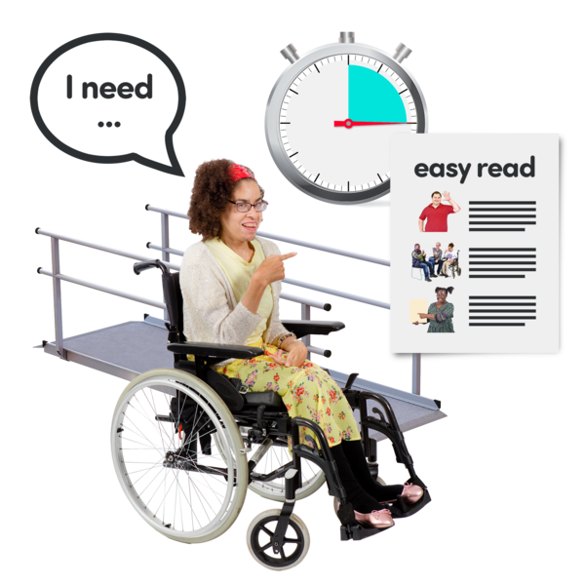  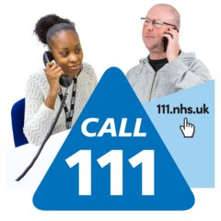  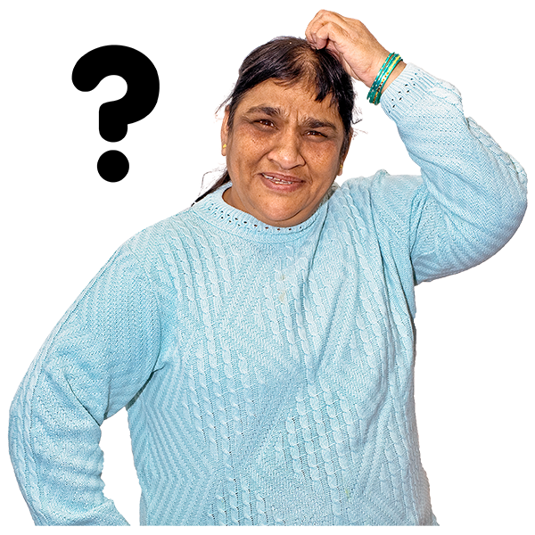  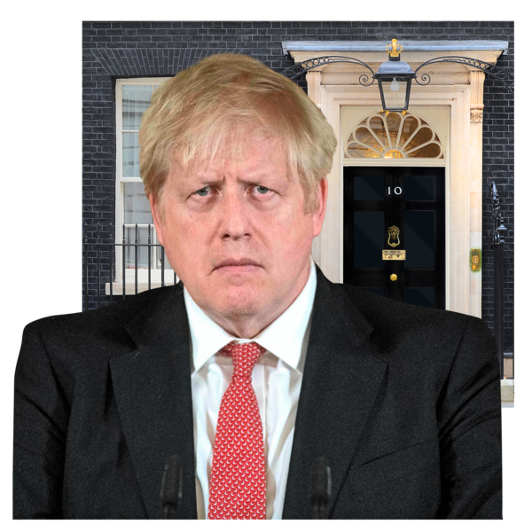 | Reasonable Adjustments  Reasonable adjustments means to make changes so that people with disabilities can use services too.  This is the law.  When Adrian felt unwell with coronavirus symptoms, Celia phoned the doctor and NHS 111.  They were told to self-isolate but did not know what self-isolate means.  No one helped them to understand what self-isolate means.  Boris Johnson sent a letter to everyone’s homes to say “stay at home”.  No one helped Adrian and Celia to read or understand the letter.  Changes were not made to the letter to help people with learning disabilities to read it.  The letter should have had pictures on to help.  Adrian felt like they were not thought of.
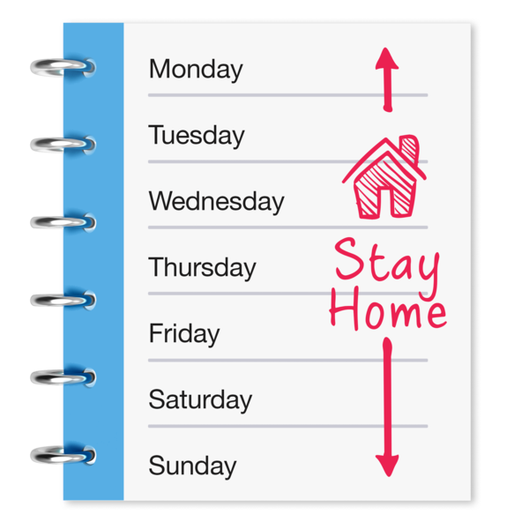  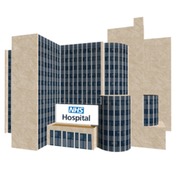  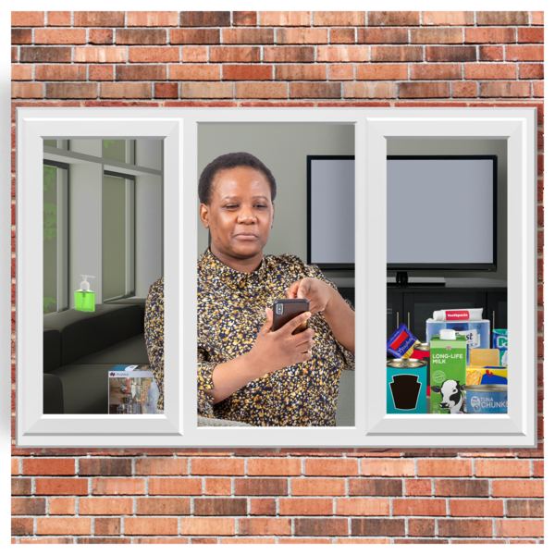  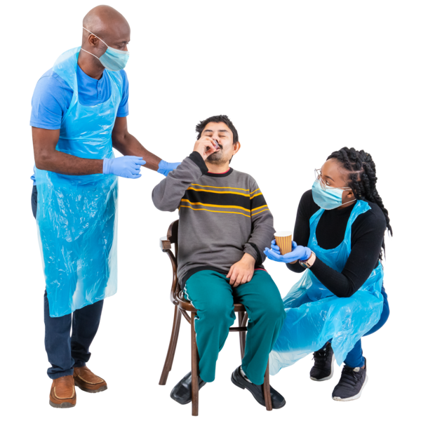  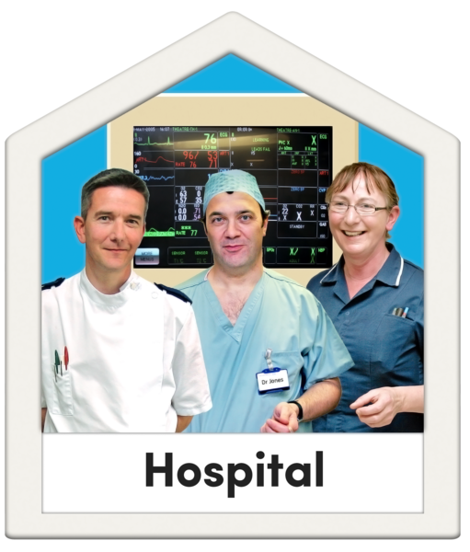 | Stay at home, suffer in silence  Celia phoned the NHS 111 service for help because she felt unwell.  Celia said that the 111 service was not helpful.  All they said was to stay at home.  This made Celia feel like she had to suffer in silence.  Everyone kept saying the message ‘stay at home’ during the lockdown.  This message was confusing because some people thought they could not leave their home even to get help in an emergency.  Celia did leave home to go to hospital for help because her cough made it difficult to swallow her epilepsy tablets.  But Celia was told to go home and was not helped, she should have been helped to take her tablets.  A few days later, Celia went to hospital and stayed overnight because of problems with her epilepsy.  She was finally tested for coronavirus. The result was positive, this means she did have coronavirus.  Celia felt annoyed that she was not tested for coronavirus sooner.  Celia felt no one listened to her.
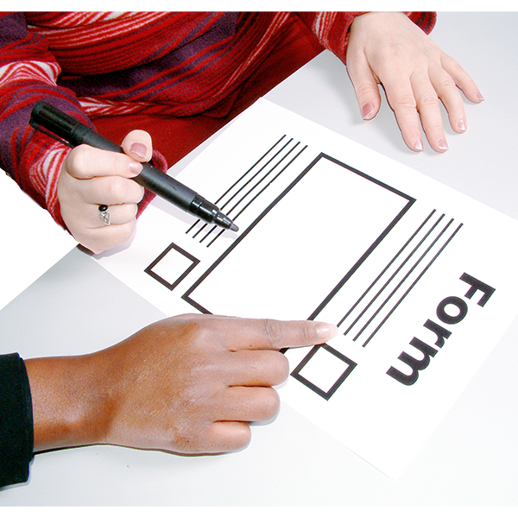  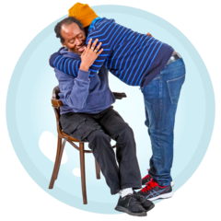  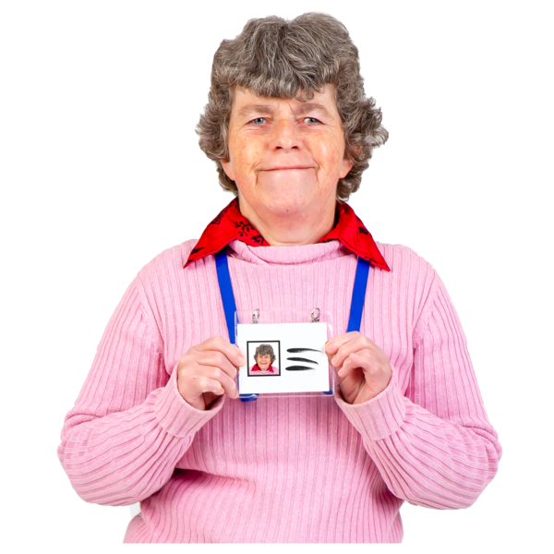  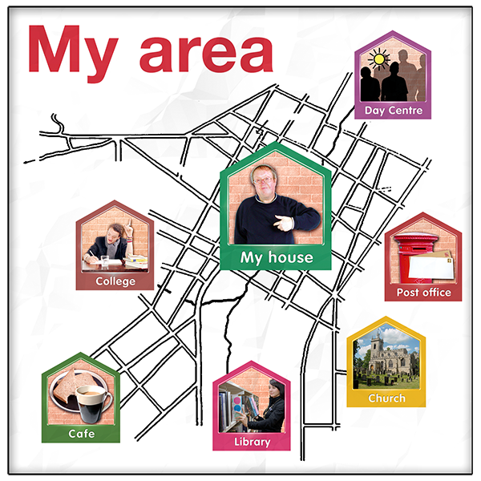 | Managing without support  When Celia was in hospital, she did not have a hospital passport to show to the doctors.  A hospital passport tells doctors and nurses about your learning disability and your support needs.  You can write about your support needs on a form to keep with you. Here is a link to the form: https://www.mencap.org.uk/sites/default/files/2020-04/C0381_NHS%20Covid-19%20Grab%20and%20Go%20LDA.pdf  While Celia was in hospital, Adrian was left on his own and he felt angry.  Celia is Adrian’s carer.  Celia did not have a Carers Emergency Card, this card can tell hospital staff that Adrian is on his own.  But not all places have Carer Emergency Cards to give to carers.
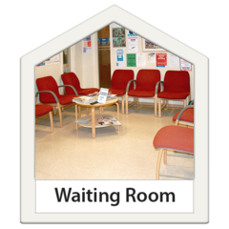  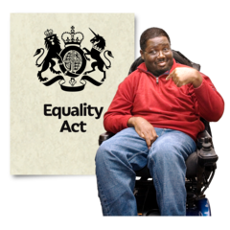 | Feeling uncared for, nothing new  Michaela asked Adrian and Celia how they feel now that they are well again.  Adrian said that he still has not had a coronavirus test.  Adrian said he feels like no one cares, that health services do not care.  Adrian and Celia talked about their past bad experiences of services.  Like waiting in waiting rooms and being insulted by doctors.  They feel angry and annoyed because these bad experiences were also happening before coronavirus.  It is important that people with learning disabilities are treated fairly and given the support that they need.  Thank you to Adrian and Celia for sharing their difficult experiences with others.
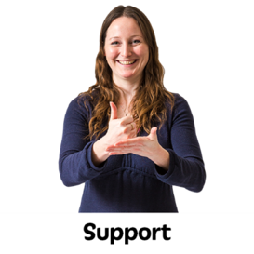  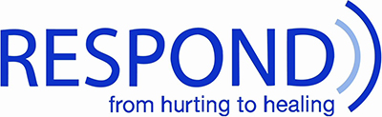  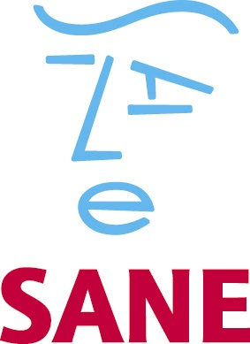 | Support  If you feel very sad or worried about coronavirus or feel you are being treated unfairly you can talk to your GP.  They can tell you about services in your area.  Here are other services that can offer support:  Respond is a charity that supports people with learning disabilities who have experienced negative experiences or trauma.  Link to website: http://respond.org.uk/who-we-are/contact/  Scottish Commission for Learning Disability -Self-help books  These books are for people with learning disabilities to help with how you feel about coronavirus and support your mental health.  Link to website with books:  https://www.scld.org.uk/covid-19-guided-self-help-booklet-series/  SANE runs a mental health helpline from 4:30pm to 10:30pm daily (0300 304 7000)

