ReadingLists@UCL: Getting started guide for MAPS

http://readinglists.ucl.ac.uk – N.B. a Firefox browser works best!

ReadingLists@UCL is a great online service that ensures students have easy access to key resources and materials to support their study wherever they are and gives academic staff the freedom to create and update their lists whenever they need.

How to set up a list: 3 steps
- Request new lists to be set up via email or online form
- You will be emailed an invitation and instructions and offered an orientation
- Turn on the ‘Library Resources’ block in Moodle (see the FAQs at www.ucl.ac.uk/library/teaching-support/reading-lists/staff)
- Build and manage your lists at your own pace
- The library will provide on-going support –
- Email: readinglists@ucl.ac.uk
- Webpages: www.ucl.ac.uk/library/teaching-support/reading-lists

You will also need to add a bookmarking button into your web browser. This is like saving a ‘favourite’ bookmark, but is easier to access.

1. From the ReadingLists@UCL homepage http://readinglists.ucl.ac.uk
2. Sign in (top right)
3. Click on ‘My Bookmarks’
4. Click on ‘Install Bookmark button’
5. Follow the instructions
6. Click ‘Next’ to move to the next instruction

7. Drag and drop the blue ‘Add to My Bookmarks’ button into the bookmarks toolbar on your browser. This creates a bookmark button.

8. To bookmark resources go to the library catalogue or any web page and click the ‘Add to My Bookmarks’ button in your toolbar.

That's all you need to do to start collecting resources.

We’ve set up a MAPS Resource list, which contains some suggestions of resources you might like to add to your online list, particularly if you don’t usually refer students to books or journal articles.

How to add a website

4. A4. Add new fields to enrienrich the data e.g. thorauthor and publisher
3. The website details will be pulled into the reading list system
1. Navigate to website or web page

2. Click the toolbar button ‘Add to My Bookmarks’

5 Click ‘Create & Add to List’ to add the reading to a particular list (a copy is also saved to your bookmarks area).
OR ‘Create’ to just save the resource in your bookmarks to add to a list in future.
5a. Click ‘create’ to just save the resource in your bookmarks to add to your list at a future date

How to find and edit your list
1. Use blue navigation links at top to visit ‘My lists’.
1. Use blue navigation links at top to visit ‘My lists’, also ‘My Bookmarks’.
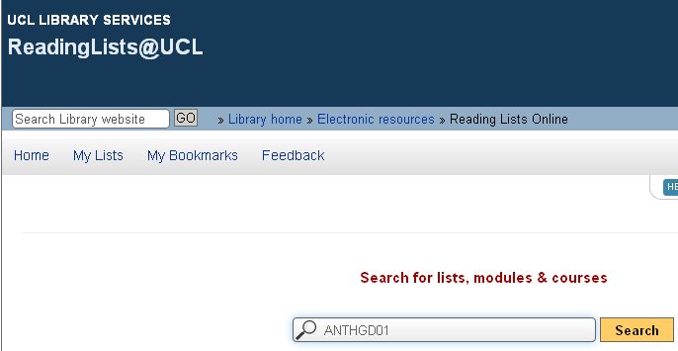
OR search for list by course code, title etc.
2. 2. Find your list then click ‘Edit’ and ‘Edit list’

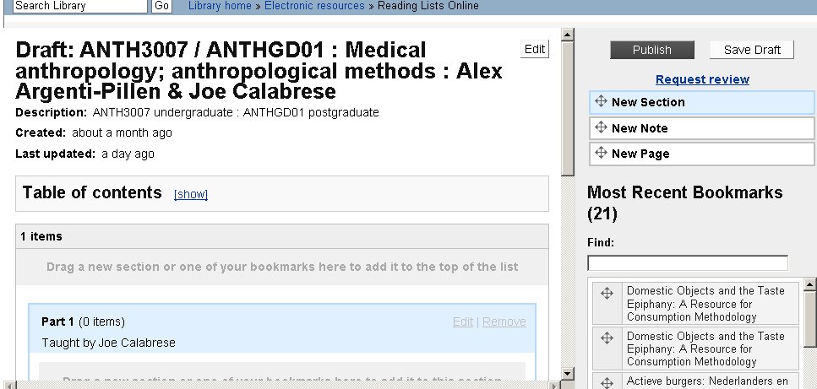
4. ‘Publish’ changes to your reading list to enable students to see the updates.
This makes the changes available immediately.
OR
‘Save draft’ - no one but you can see the changes.

3. To add previously bookmarked readings, use the star-icon buttons to drag and drop into the list

Suggested resources for MAPS online lists

A reading list that includes references to books and journal articles may not be relevant for all modules. The lists can be used to link to any online resource – from a video clip in YouTube to a Learned Society web page. We have therefore put together a list of a few key resources that students should find helpful to give some ideas of what the system could be used for. These have all been added to an online list: http://readinglists.ucl.ac.uk/lists/EA04BB82-B580-35A6-DB73-E81E30DC495B.html

All subject areas

Database - Web of Science: https://apps.webofknowledge.com/

E-book or E-chapter - The Complete Guide to Referencing and Avoiding Plagiarism

http://readinglists.ucl.ac.uk/items/1DBA2196-0299-D521-ADC4-FE013C432A83.html?referrer=%2Flists%2FB97BAF79-7A1A-19DE-3499-A7892C0D72EA.html%23item-1DBA2196-0299-D521-ADC4-FE013C432A83

Encyclopedia - Encyclopædia Britannica Online: http://www.britannica.com/

Library induction: http://www.slideshare.net/librxt/library-inductionwelcome

Past exams: http://digitool-b.lib.ucl.ac.uk:8881/R&?local_base=EXAMPAPERS

Chemistry

BoB Programme - Chemistry: A Volatile History:
http://bobnational.net/record/21983

Handbook - CRC handbook of chemistry and physics: a ready-reference book of chemical and physical data: http://www.hbcpnetbase.com/

Earth Sciences

Book - The solid earth: an introduction to global geophysics
http://ucl-primo.hosted.exlibrisgroup.com/UCL_VU1:UCL_LMS_DS001129882

Departmental webpage: http://www.ucl.ac.uk/earth-sciences

Maps geospatial data: http://digimap.edina.ac.uk/digimap/home

Mathematics and Statistical Science

Learned Society - London Mathematical Society (LMS): http://www.lms.ac.uk/

Instructors’ webpage: http://www.ucl.ac.uk/statistics/research/researchers

Physics and Astronomy

Digitised reading of a chapter - The solid earth: an introduction to global geophysics by C.M.R. Fowler: http://readinglists.ucl.ac.uk/items/2000D503-7E23-B15B-16D8-F714E1222AD3.html?referrer=%2Flists%2F63ED10F1-C245-EB1A-FA50-64B68BEB5DA4.html%23item-2000D503-7E23-B15B-16D8-F714E1222AD3

Seminars and events: http://www.ucl.ac.uk/phys/news/eventsgoogle

Science and Technology Studies

Link to course syllabus/ classroom slides or VID: http://www.ucl.ac.uk/sts/study/hpsc

Subject Support Guide
http://www.ucl.ac.uk/library/subject-support/guides/science-tech

