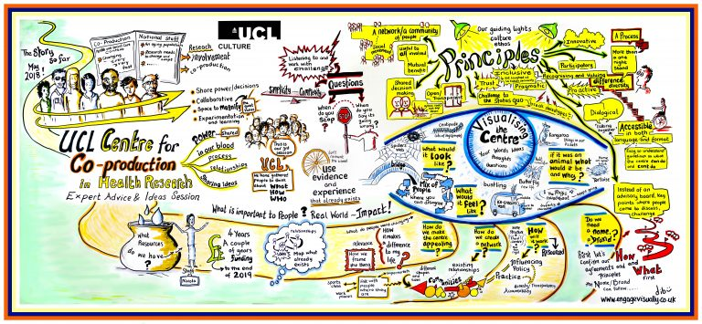

UCL Centre for Co-production in Health Research

Virtual Sessions Summer 2020

Join us to continue co-producing the development of the Centre!

- Co-creation Sessions

Co-creating our strategy
What are we working towards and how will we know if we’re getting there?

- Part One: Wednesday 3 June 14:00 - 16:00
- Part Two: Monday 8 June 14:00 - 16:00
- Additional sessions and ways of getting involved - coming soon!

Co-creating our identity
Developing our brand and website

- Dates in Summer 2020 - coming soon

2. Co-production Network Sessions
Join us for a cuppa and a chat! Come together to meet others in our community, hear from someone who has been there and done it, and come away with new ideas.

- Tuesday 12 May, 14:00 - 16:00
- Tuesday 14 July 14:00 - 16:00
- Additional dates to follow shortly

How do I join a session?

To sign up to any of these sessions, please email Rory on coproduction@ucl.ac.uk and let her know that you are keen to join a session (or sessions!), the date and how you would like to join:
- Zoom call
- Conference call
- Or other method

Rory will then share the information you need to join the session(s).

We ran a poll on Twitter and called or emailed as many people as we could to find out how you would prefer to join these virtual sessions. The winners were Zoom for online, and conference calls for offline. However, we are aware that these methods will not work for everyone so we are also planning to share for your input what we are working on as a community in other ways - via Google docs, via printed and posted papers, via any other methods that we come across in the coming months.

If Zoom or conference calls don't work for you, but you’re still keen to get involved, then we still want to hear from you – please get in touch for a chat so we can work out the best way to get you involved.

