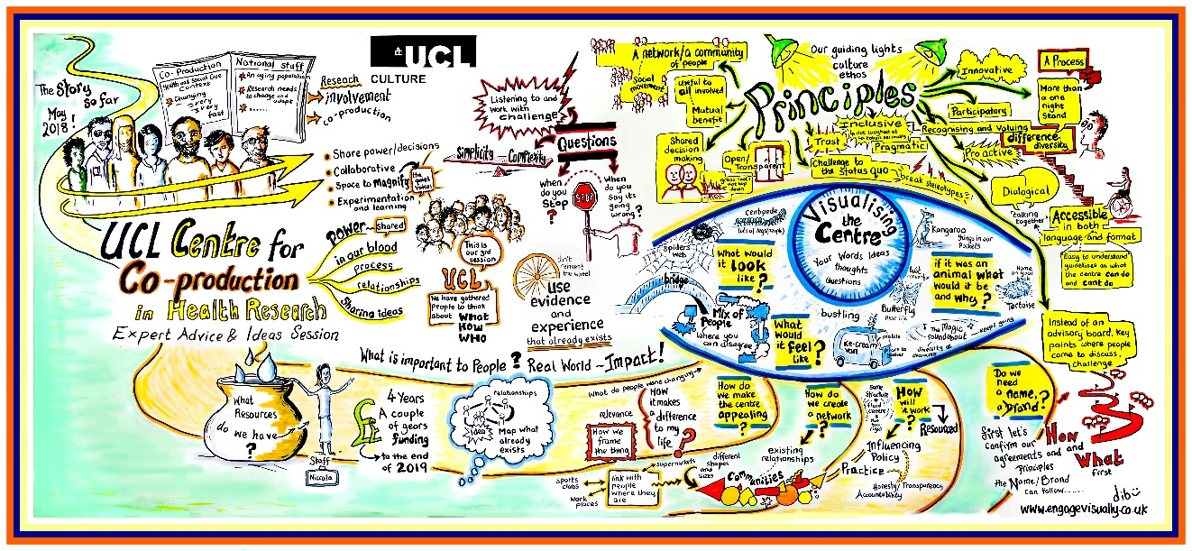
Document 2:
UCL Centre for Co-production in Health Research
**Application Form - Pilot Projects Phase 2, 2019**
Please read Document 1: Pilot Projects Phase 2 FAQs before completing your application – it provides information about eligibility and our principles as a Centre for Co-production.

What are these Pilots about?
The UCL Centre for Co-production in Health Research is currently under development. Significant progress has been made since we started in October 2017. This is our second round of pilots, which will run from July 2019 to end of February 2020. You can read more about the first round of Pilots and the latest updates about the Centre in our previous blog posts.

We are looking for co-production projects (innovation, research or intervention) to Pilot in order to help us:
- Identify how the Centre’s approach to co-production will strengthen and improve health research design and delivery
- Bring the Centre to life by further developing resources, toolkits and a visual identity/brand and a community of expertise and experience
- Decide upon future ways of working, in terms of both the processes which underpin our operations, and the learning and development in co-production we offer all involved

Who can apply for funding?
Anyone who is interested in being part of the Centre movement to rethink the way health research is developed. And anyone who would like to include genuine collaboration and co-production between communities, researchers and healthcare practitioners in their research, intervention or project.

Are there any criteria that the Centre will be looking for those who apply for funding to meet?
Yes. See Document 1 – Pilot FAQs Q6 for further information.

How do I apply for funding?
Please answer all of the questions outlined below and submit your answers in one of the following formats by midnight on Friday 14 June 2019.

Submission formats include:
- Complete the below form and email a copy (typed or hand written/scanned) to Niccola at n.pascal@ucl.ac.uk (make sure you read The Nitty Gritty section at the end of this document first!)
- OR… Make a video or audio recording (on your phone or other device) of your answers to the questions outlined below and email a video or audio file to Niccola at n.pascal@ucl.ac.uk

Timeline – outlined below is the approximate timeline for set up and delivery of the Pilots.
- Deadline for applications – midnight on Friday 14 June 2019.
- Panel review of submissions – Monday 17 June – Friday 28 June 2019. Applications will be considered by a Review Panel composed of Centre collaborators (those not applying for funding themselves), representatives from UCL and patient and community partners.
- Notification of decisions – by end Monday 1 July 2019.
- Funding distributed – Monday 1 July – Friday 12 July 2019.
- Kick-off Meeting – Tuesday 9 July 2019.
- Pilots live – by end of July 2019 to end of February 2020.

If you would like assistance with applying or have any questions please feel free to contact Niccola on n.pascal@ucl.ac.uk or call 07741 671 200.

The Application Form follows on this page. If the formats available do not work for you please feel free to contact Niccola to ask for an alternative.

Application Form

Proposed Pilot project title
Insert answer here.

Amount requested (£10,000 – £15,000 available per project)
Insert answer here.

Pilot project start and end dates
Insert answer here.

Co-applicant names and organisation (if relevant), or UCL department/institute (if relevant) or interest area (Please note: your team involved from outset must be a mixed group of at least three people – see the Pilot FAQs Document 1 and The Nitty Gritty section for further information)
(E.g. Jenny Bloggs, community health. Or, e.g. Joe Bloggs, Age UK. Or, e.g. Jack Bloggs, UCL Institute of xxx).
Insert answer here.

Person(s) to contact about the application
Name(s) - Insert answer here.
Phone(s) - Insert answer here.
Email(s) - Insert answer here.

Q1. Please state the aims of your proposed co-produced Pilot project for both the community and research
Insert answer here.

Q2. WHAT do you seek to achieve through this activity? Please describe briefly, what will happen in your proposed pilot project and how you will ensure that the project is co-produced?
Insert answer here.

Q3. WHO is involved in running the project? Please give details of all collaborators, their roles, and a short summary of any relevant experience.
Insert answer here.

Q4. HOW will you assess whether you have achieved the aims detailed in Q1?
Insert answer here.

Q5. How does this co-production Pilot project benefit the local community? We particularly welcome a focus on ‘less often-heard’ voices within the community local to UCL and UCL East, the London borough of Camden and East London.
Insert answer here.

Q6. Please include a brief timeline of when planning and activities will happen if this proposal is funded.
Insert answer here.

Q7. Please provide a breakdown of the amount requested – what will the money be spent on? Please also provide details of any funding or resources (including value in kind resource) coming from elsewhere.
Insert answer here.

Q8. How will you ensure long-term sustainability for this piece of work?
Please outline your plans following this Pilot and who will be involved in taking this forward (e.g. any outcomes or outputs which are anticipated; any additional partners you will seek to involve; additional funding applications you will make etc.).
Insert answer here.

Please submit your application by midnight on Friday 14 June to n.pascal@ucl.ac.uk.

In addition, if you have any feedback about this application process, please contact Niccola to share any thoughts you have.

The NITTY GRITTY

To be eligible ALL applications MUST:
- Include applicant groups of minimum three people and there should be:
  - At least one patient/public/community co-applicant (preferably two)
  - At least one researcher and/or health care professional co-applicant (preferably one of each)
- Include authentic co-production (or other variants of this approach – see Pilot FAQs Q7 for further information) as the main methodological approach.
- Have been born out of community identified need.
- Consider appropriate recognition for patient/public/community involvement in co-production of the Pilot project (e.g. expenses reimbursement, payment for time etc.) Read the NIHR Guidelines.

Additional info:
- This funding can be used to seed-fund future work (e.g. setting up a project steering group, assessing a need within a community, developing a tool etc.).
- The project does not need to be finished at the end of the seven-month period however, you will be required to have completed the work outlined at application and to report back (template will be provided) at the end of the pilot period (end of February 2020).
- We are unable to fund work that has already started, or work that is not collaborative and does not include co-production (or other variants of this approach) as the main methodological approach.
- If you were part of one of the first series of Pilots (September 2018 – December 2018) you are still eligible to apply for funding provided you can clearly demonstrate how the project differs from your original Pilot or how it significantly advances the work conducted during the first series of Pilots.
- We may come back to you to ask you for a more detailed breakdown of costs.
- The successful applicants agree to uphold the UCL Centre for Co-production Principles of Co-production during their Pilot project. See Document 1: Pilot Projects Phase 2 FAQs for further information.
- We particularly welcome applications that focus on ‘less often-heard’ voices within the communities local to UCL and UCL East and the London borough of Camden and East London.
- All successful projects are required to commit at least one member of the team to attend each learning/co-creation session and where possible any additional optional sessions (as outlined in Document 1 FAQs Q12).

By applying for UCL Centre for Co-production in Health Research Pilot project funding you have automatically signed up to receive updates and news. Please tick this box or write ‘no’ next to this text if you would prefer not to receive this communication. ☐

