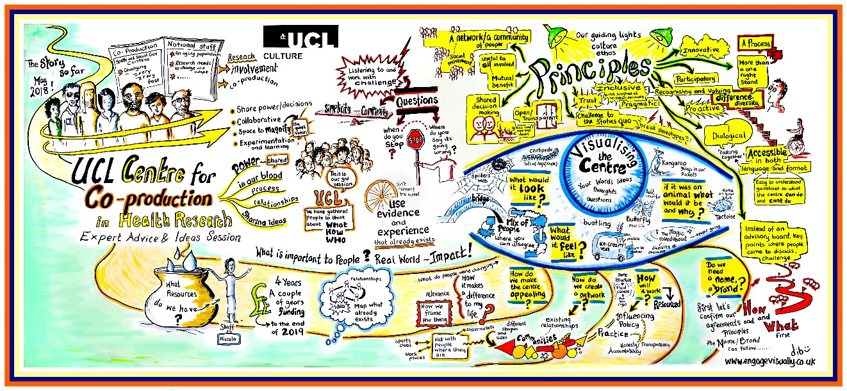

**Document 1:**

**UCL Centre for Co-production in Health Research **Pilot FAQs – Pilot Projects Phase 2, 2019 \*\***

The UCL Centre for Co-production in Health Research has reached a stage in its development where we are looking to identify a second phase of Pilot projects. We are keen to further test and refine our approach. We are looking for collaborators (organisations or groups of individuals) who are interested in delivering a co-production innovation, piece of research or intervention project.

In 2018, we ran the Co-pro Pilots Phase 1; those funded ranged from an innovation sandpit focusing on how to improve communication in healthcare settings for those with mild to moderate hearing loss, to co-producing an evaluation strategy for a small community organisation. We all learnt masses! You can read more about the Pilots and Centre development so far below and in our [Centre blog posts](https://blogs.ucl.ac.uk/public-engagement/category/co-production/).

The Centre is due to officially launch in mid-2020 and we know there is still lots more to learn (you never stop learning, right!). So… we are ready for Co-Pro Pilots Phase 2! Join us to explore this innovative approach to health and social care research.

Image credit and info

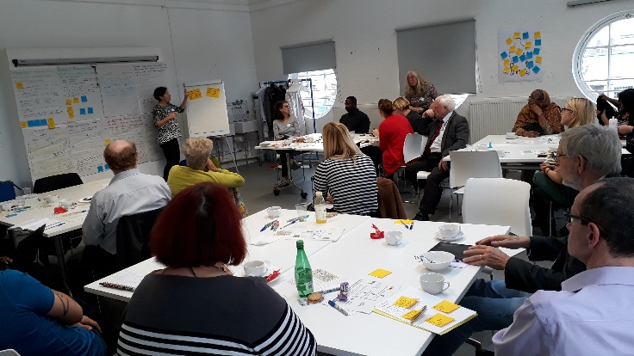

*Image info: A UCL Centre for Co-production development session – a room of people having a discussion with colourful post-it notes on the walls and tables.*

Before you read on though, **please note…** we are not your average Research Centre. We are aiming to do things **DIFFERENTLY!** You will notice this reflected in the principles we live by as a Centre and in our approach to the development of the Centre so far – please have a look at [Debbie’s graphic illustration](http://blogs.ucl.ac.uk/public-engagement/files/2018/07/DebbieGraphic.pdf) of some the work we have done to date. As you will see, we aim to focus on quality of life and people’s views of the best way to maximise it, rather than statistics or morbidity.

We are only a small way down the road and don’t have all the answers, but… we are very passionate and dedicated! So, we’re inviting potential partners to help us learn and develop what we do.

Still interested? Great! Please read on, we have outlined answers to a few questions. Feel free to ask for documents in other formats if theses ones don’t work for you.

[](http://www.ucl.ac.uk/)

**Q1: What is the UCL Centre for Co-production?**

Our vision is that the Centre will…

* Provide space(s) (physical and/or virtual) where everyone involved is part of the crowdsourcing of project ideas
* Focus on co-producing health research which addresses the health and social care priorities of ‘less often heard’ voices/communities
* Deliver a series of innovations, products or interventions that will improve health and wellbeing
* Develop accessible online communities and interactive resources that will help facilitate exchange of knowledge between those involved
* Reflect, evaluate and share its learning to improve the way health and social care research is designed, delivered and disseminated
* Support, and help further the social movement in the area of co-production (nationally and internationally), by working in partnership to raise awareness and further develop the case for co-production in research, policy and service development.

*Image info: Two images of Centre collaborators co-producing the Centre development, one includes a Guide dog relaxing whilst off duty!*

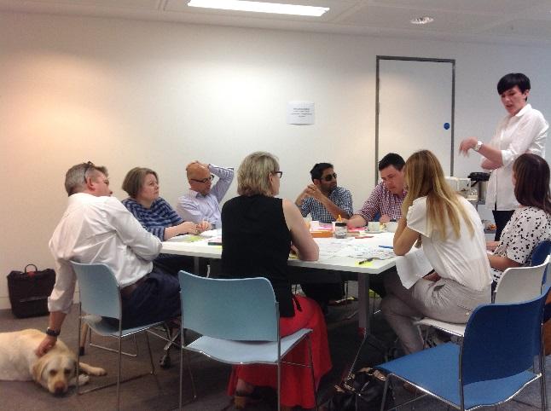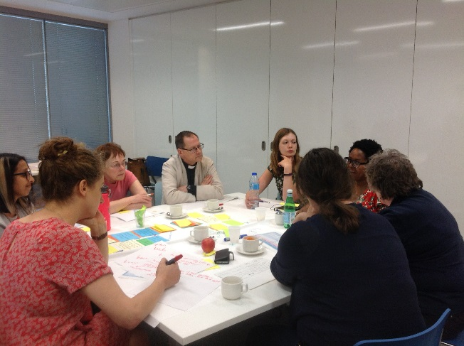

**Q2: What do we mean by co-production?**

*“Co-producing research is an approach to research in which researchers, practitioners and public work together, sharing power and responsibility from the start to the end of a research project, including the generation of knowledge” (INVOLVE 2018).*

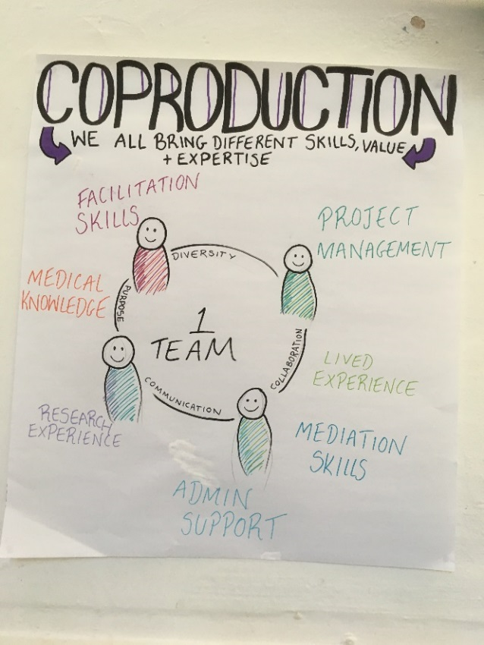

*At the Centre, we see ourselves as ONE team! One team of people with different types of expertise, but no single person’s expertise (whatever area it is in) is more or less important than anyone else’s. It is different, which provides a wealth of experience and perspectives.*

*Image info: Left – diagram of the skills and expertise that make up a co-production team. Right – picture of the definition of collaboration.*

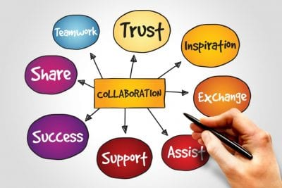

**Q3: What are the principles that underpin the UCL Centre for Co-production?**

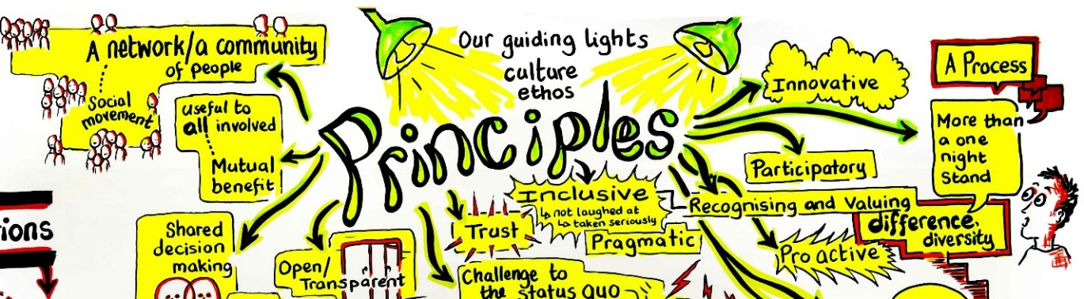All interaction will be based on the principles we as a Centre want to live by. These are:

*Image info: A graphic illustration of the UCL Centre for Co-production principles to live by.*

* Respecting diversity of experience and perspective
* Collective decision-making
* Commitment to addressing power imbalances
* Understanding the meaning of and fostering authentic co-production
* Challenging the status quo
* Being accessible to and inclusive of all
* Ensuring mutual benefit for all
* Being open, transparent and honest - yet pragmatic and real
* Checking and challenging throughout
* Encouraging innovative practice
* Ensuring sufficient resourcing & sustainability

**Q4: Why are we planning Phase 2 of the Co-pro Pilots?**

We are currently still working to co-produce the development of the UCL Centre for Co-production in Health Research and to bring it to life! As part of this development work, we are conducting a second phase of Pilot projects to further test our co-produced plans for the Centre, and generate more evidence about how co-production can make a difference in health research (have a read of our [Centre blog posts](https://blogs.ucl.ac.uk/public-engagement/category/co-production/) to find out more about the first round of Pilots in 2018). There is **£10,000 - £15,000** of funding available to apply for **per project**; we plan to fund **3 or 4 projects** from **July 2019 to February 2020**.

The priorities for the Pilot projects are to help:

* Identify how the Centre’s approach to co-production will strengthen and improve health research design and delivery
* Bring the Centre to life by further developing resources, toolkits and a visual identity/brand and a community of expertise and experience
* Decide upon future ways of working, in terms of both the processes which underpin our operations, and the learning and development in co-production we offer all involved

**Q5: Who can get involved? What skills and expertise are we looking for?**

Anyone who is interested in being part of the Centre movement to rethink the way health research is developed. Anyone who would like to include genuine collaboration and co-production between communities, researchers and healthcare practitioners in what they do can get involved. We would love to hear from you!

We particularly welcome interest from individuals and organisations from the communities local to UCL and UCL East, the London borough of Camden and East London and projects, and applications that focus on less often-heard voices from these areas.

Please note: the minimum number of people per Pilot project team is three. Each team should include:

* At least one patient/public/community co-applicant (preferably minimum two)
* At least one researcher and/or health care professional co-applicant (preferably one of each)

**Q6: What kind of Pilot projects are we looking to fund?**

[](http://www.ucl.ac.uk/)We want to fund Pilot projects, which involve people from a range of different backgrounds co-producing a health and social care innovation, intervention or research project, which addresses the priorities of ‘less-often heard’ voices or communities. Projects should involve people from those communities as equal collaborators with researchers, healthcare practitioners, or anyone else who is involved. We have no expectations or requirements about what the projects should produce by the end, but we want to see how co-production can make a difference in this area.

Outlined below are the criteria that the Applications Review Panel (a mixed group of Centre collaborators) will score against when assessing applications received. Funding will be awarded to the 3 or 4 projects that mostly closely meet with set of criteria.

Criteria 1: Addressing the principles of co-production – 20% weighting

* Do applicants understand and have they embraced the principles of co-production and the Centre?

Criteria 2: Meeting the Centre priorities – 20% weighting

* Have applicants outlined clear evidence of how the project will help the Centre to meet at least one of the Pilot priorities (outlined above in Q4)

Criteria 3: Planning – 40% weighting

* Is the plan for the Pilot project clear and well thought out? Are there clear aims and objectives, a project plan and project timeline?

Criteria 4: Ensuring sustainable benefits – 10% weighting

* What thought does the application give to sustainability post Pilot? Is there an exit strategy or plan outlined?

Criteria 5: Project costs – 10% weighting

* Are the costs of the project reasonable? Does the application include payment of community members or patients where appropriate? Has other funding/value in kind support been sourced?

**Q7: What if we are considering an application for Pilot project but we aren’t sure if it is co-production? Can we still get involved?**

Yes. We welcome applications from those using a wide variety of collaborative methods as long as you are an inclusive team that embraces the principles of co-production that the Centre aims to live by (see Q3).

**Q8: Can I apply for Pilot funding as an individual?**

No. A key requirement of the Pilot projects is that you apply as a team. Should you require support with finding potential collaborators or with a place to meet up please contact Niccola for assistance. We have a wide network of potential collaborators interested in this way of working and plenty of ideas up our sleeve!

**Q9: Can we apply for funding if we were involved in the first phase of Pilot projects that took place between September 2018 and December 2018?**

Yes, provided you clearly demonstrate how the project differs from your original Pilot or how it significantly advances the work conducted during the first phase of Pilots and draws on the learning which emerged.



**Q10: What other type of help is available (in addition to funding) to support this work?**

Some of the learning from the last phase of pilots was that what people really want when co-producing is help and guidance from someone who has been there, done that and got the t shirt!

We will be running the Kick-off Meeting (which will include some learning and development) plus various co-creation/networking sessions alongside the Pilot activity. In addition, this time around we will be offering the chance for you to buddy up with someone to receive guidance – by phone, email or at Centre co-creation sessions. See the timeline (in Q12) for further info.

*Image info: Two people holding up a ‘Buddy up’ sign (Credit: http://www.crisni.org)*

**Q11: What if I’m not ready or able to be involved in a Pilot project?**

If you have ideas of your own and would like to be involved in the co-production of the Centre rather than a Pilot project, we would love to hear from you too! We’re also happy to hear from anyone who just wants to be kept updated on the Centre’s progress.

Please email [n.pascal@ucl.ac.uk](mailto:n.pascal@ucl.ac.uk?subject=UCL%20Centre%20for%20Co-production%20-%20please%20keep%20me%20up%20to%20date). We share regular newsletter updates via email, blogs, webinars and other events.

[](http://www.ucl.ac.uk/)

Also, please feel free to pass on this info on to anyone that you think will be interested.

**Q12: What is the timeline for the Pilot projects and what are the expectations if we’re successful in securing funding?**

See the table below for an outline. This information will be shared in more detail at the Pilot Kick Off meeting on **Tuesday 9 July**.

|  |  |  |
| --- | --- | --- |
| **Date** | **Event / action** | **Expectations of applicants** |
| Tuesday 30 April 2019 | Applications open | Get planning! We are looking out for enthusiasm and great co-production ideas |
| Midnight Friday 14 June 2019 | Deadline for applications | Don’t forget! ☺ |
| Monday 17 June – Friday 28 June 2019 | Application Review Panel meeting takes place – panel will be a mixed group of member of the local community, patients, carers, researchers and healthcare practitioners | None |
| Before Monday 1 July 2019 | Successful applicants notified | Get excited! |
| Tuesday 9 July 2019, 13:30 – 16:30 | Pilots Kick-off Meeting and evaluation co-creation session   * Chance to meet a potential co-production buddy for you and your Pilot team | Minimum 3 of the Pilot co-producers team per project required to attend (if more of the team are available please do feel free to come along) |
| Monday 1 July – Friday 12 July 2019 | Funding to be distributed to successful Pilot projects | One member of Pilot team to liaise with UCL to organise this |
| Before Wednesday 31 July 2019 | Pilot project work starts | All Pilot projects need to have kicked off |
| Ongoing from 1 August 2019 to February 2019 | Co-creation sessions – learning and development/peer support for Pilot team’s and Centre development work   * Chance to meet up with your co-production buddy | At least one member of the Pilot team required to attend each session – approximately 9 half day sessions planned |

*Table outlining the detailed timeline for the Pilots work (please ask if you would like this explained in more detail)*

**Q13: What is the overall timeline for the Centre development work?**

See timeline below.

|  |  |  |  |  |  |  |  |  |  |  |  |
| --- | --- | --- | --- | --- | --- | --- | --- | --- | --- | --- | --- |
| **Jul 19** | **Aug 19** | **Sep 19** | **Oct 19** | **Nov 19** | **Dec 19** | **Jan 20** | **Feb 20** | **Mar 20** | **Apr 20** | **May 20** | **Jun 20** |
| Pilots Phase 2 start |  |  |  |  |  |  | Pilots Phase 2 end |  |  |  |  |
|  | Centre co-creation sessions take place – evaluation framework development, Centre brand/logo, Centre website and resource bank | | | | | | |  |  |  |  |
| Centre business model and the case for co-production/collaboration in research is generated | | | | | | | | | | | |
|  |  |  |  |  |  |  |  |  |  | Centre officially launches | |

Table outlining the overall timeline for the Centre development work (please ask if you would like this explained in more detail)

**Q14: What’s next?**

You simply need to get in touch. There are 2 different ways that you can get involved in the UCL Centre for Co-production in Health Research work at the moment. They are:

1. **By applying for funding (£10,000-15,000 per project) to deliver a co-production Pilot project** (innovation, research or intervention). Please complete the attached Application Form (Document 2) and email your submission to [n.pascal@ucl.ac.uk](mailto:n.pascal@ucl.ac.uk?subject=UCL%20Centre%20for%20Co-production%20Application)
2. **By expressing an interest in being part of the Centre co-production team working to develop the Centre** – this opportunity is open to anyone who would like to get involved, no previous experience required.

[](http://www.engagevisually.co.uk/)

If you have any questions, feedback, want to get involved or would like assistance with applying please get in touch with Niccola Hutchinson-Pascal [n.pascal@ucl.ac.uk](mailto:n.pascal@ucl.ac.uk), 07741 671 200.

The deadline for applying for Pilot project funding is **midnight on Friday 14 June 2019**.

We look forward to hearing from you! Thank you,

*Image credit: Engage Visually – Debbie Roberts*

**The UCL Centre for Co-production in Health Research Collaborators**