How to respond if bullying or harassment is reported to you

Guidelines for managers
These are brief guidelines to help you to know what to do if bullying or harassment is reported to you* and are aimed at achieving resolution informally. They do not replace the UCL guidelines** that have further detail and include the formal process should informal resolution not be possible.
The ﬂow chart on the next slide covers most situations but remember:
Doing nothing is not an option -­‐ it condones harassment – protecting a bully is not a strategy for protecting the department or institution

- If this is a repeat occurrence or gross misconduct
https://www.ucl.ac.uk/human-resources/sites/human-resources/files/disciplinary-appendix-a-misconduct-and-gross-misconduct.pdf, please refer the person directly to HR (Gill Tunstall)
**
https://www.ucl.ac.uk/human-­‐resources/equality-­‐diversity-­‐inclusion/dignity-­‐work/dignity-­‐work-­‐statement
4th September 2018

NO
YES
YES
Send a follow up email to the complainant-­‐ are things resolved?
YES
NO
Report to SMT / HR/manager preserving anonymity of complainant if requested

No further action
Talk to them preserving anonymity of complainant if requested
Talk to their manager preserving anonymity of complainant if requested (and if advisable)
YES
Is Person X someone you manage?
Discuss the options, make a plan and send a follow up email
NO
Are they a colleague you feel able to approach informally?

* See Appendix A for tips on discussing with complainant

** See Appendix B & C for deﬁnitions of bullying and harassment

*** see Appendix E for tips on discussing with the person being complained about

**** UCL has a duty of care towards staﬀ and students-­‐ -­‐ seek advice from HR if you are unsure
NO
Do you think this may be a case of bullying or harassment?**
It’s not your job to prove it
Explain what constitutes bullying and harassment and where further information/ advice is obtainable***
Listen, empathise*
Staﬀ/student reports to you alleged bullying/harassment by Person X

Appendix A

Informally responding to complaints
  - Be supportive, actively listen, be non-­‐prejudicial
  - Do not make promises about conﬁdentiality: UCL has a Duty of Care
  - Explain that the informal process is about resolution – not proof or substantiation.
  - The aim is to prevent the issues reoccurring, not ‘punishing’ the respondent
  - Explain the options, i.e. addressing the matter directly with the respondent, or more subtle interventions
  - Explain that a formal complaint can be made at any time – seeking informal resolution is not a barrier to a formal complaint later
  - Be clear about when you think informal resolution is inappropriate
  - Do not over-­‐promise a result – investigations can be diﬃcult and multi-­‐faceted
  - Follow up the meeting in writing. For example…
    - I conﬁrm we met yesterday.
    - We discussed options for resolution of this issue and you indicated that you would like to pursue an informal resolution.
    - We agreed that I/we/you would [speak to your colleague, etc..]
    - Following this, if the matter hasn’t been resolved you can make a formal complaint at any time [https://www.ucl.ac.uk/human-resources/ucl-staff-grievance-policy],

3

Appendix B

Deﬁnitions of Bullying and Harassment
Harassment is: ‘Unwanted conduct related to a relevant protected characteristic, which has the purpose or eﬀect of violating an individual's dignity or creating an intimidating, hostile, degrading, humiliating or oﬀensive environment for that individual‘

Equality Act 2010

Bullying has no formal legal deﬁnition but is usually characterised as: ‘oﬀensive, intimidating, malicious or insulting behaviour, or misuse of power through means intended to undermine, humiliate, denigrate or injure the recipient’

Bullying does not have to be related to a protected characteristic, occurs from a position of strength (seniority, numbers, etc.), involves a pattern of behaviour and can entail excluding individuals.

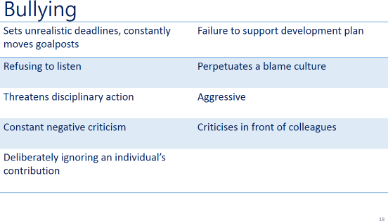
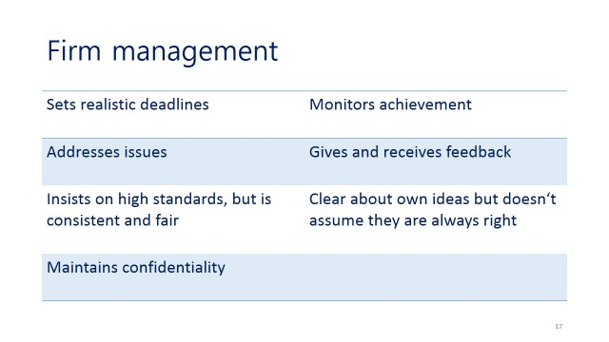
Bullying
Appendix C
Appendix E

Speaking to the person who is being complained about
- If the complaint is anonymous, you should protect the identity of the individual and only address the complaint in very general terms, either individually or in larger groups. For example:
“I’ve been made aware that there have been complaints about bullying in your team/research group. I cannot go into speciﬁcs. What is your perspective on this? Does everyone in your team understand the deﬁnition of harassment and bullying and its impact? Are you / they aware of UCL policy and the standard expected of employees, are you advised of the consequences if a complaint is investigated and upheld? ”

- If not anonymous, use the DESC model:
  - Describe the behaviour – say what, when, who, where – be speciﬁc
  - Explain the eﬀect –on others
  - Say what you want to happen – be clear, polite but ﬁrm that action is needed
  - Contract/consequences – aim for agreement, but if not willing be honest about consequences

  - Explain that victimisation is serious misconduct
7

