How to respond if you witness bullying or harassment

Options for bystanders
These are brief guidelines giving options of what you can do if you witness bullying or harassment. They do not replace the UCL guidelines* that have further detail and include the formal process where informal resolution is not possible.

The ﬂow chart on the next slide covers most situations and local advice is available from the DEOLO, Dignity at Work advisor, HR Advisory and Trade union.
Remember:

Doing nothing condones harassment – protecting a bully is not a strategy for protecting the department or institution
https://www.ucl.ac.uk/human-resources/equality-diversity-inclusion/dignity-work/dignity-work-statement

4TH September , 2018

Follow-­‐up with either party at a later date when they are calm
You witness what appears to you as
*bullying/harassment by person X

Decide to intervene during the incident
Decide to intervene after the incident

and/or
- Replay what you have observed
- Explain why you feel uncomfortable
- Change the focus, interrupt or distract
- Don’t laugh, respond or
engage
- Talk to them conﬁdentially
- Replay what you observed
- Explain why you felt uncomfortable
- Ask if they want to discuss the situation and listen sympathetically
- Advise them of sources of support (e.g. DEOLO, Dignity at Work Advisors, HR, managers)
YES
Report to HR/ your manager/ SMT
Report to the manager of person X
YES
- Talk to them conﬁdentially
- Replay what you observed
- Explain why you felt uncomfortable
Do you feel able to approach their manager?
NO

Do you feel able to approach them informally?
NO

* See Appendix A & B for deﬁnitions of bullying and harassment

Indirect
(to the receiver)
Direct
(to person X)

Appendix A

Deﬁnitions of Bullying and Harassment
Harassment is: ‘Unwanted conduct related to a relevant protected characteristic, which has the purpose or eﬀect of violating an individual's dignity or creating an intimidating, hostile, degrading, humiliating or oﬀensive environment for that individual‘

Equality Act 2010

Bullying has no formal legal deﬁnition but is usually characterised as: ‘oﬀensive, intimidating, malicious or insulting behaviour, or misuse of power through means intended to undermine, humiliate, denigrate or injure the recipient’

Bullying does not have to be related to a protected characteristic, occurs from a position of strength (seniority, numbers, etc.), involves a pattern of behaviour and can entail excluding individuals.

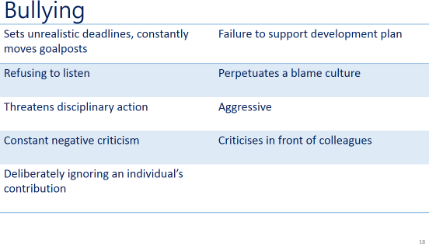
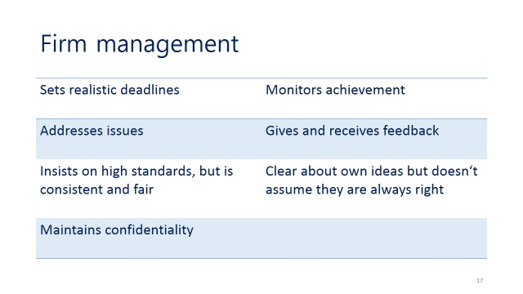
Bullying versus Firm Management
Appendix B

By challenging inappropriate behaviours we can all play a role in ensuring that UCL is a harassment free zone.

