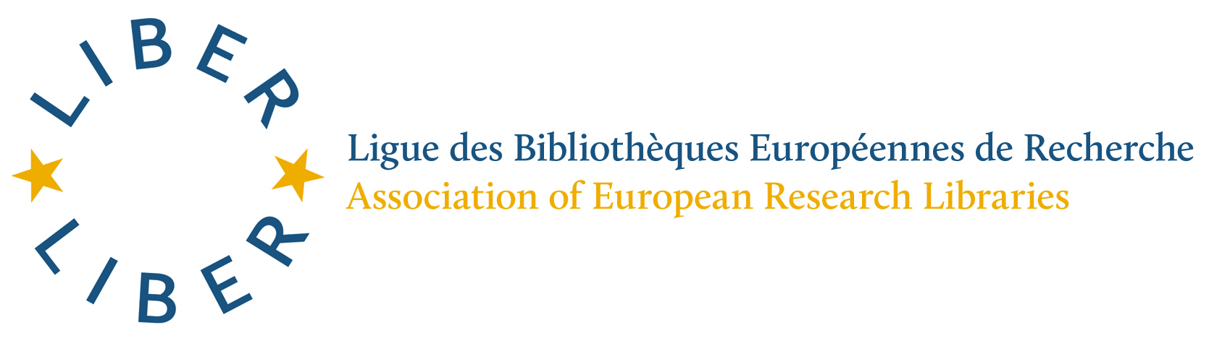

Introduction
LIBER (Association of European Research Libraries) was founded in 1971. An Association (a Foundation or Stichting under Dutch law from 2009), LIBER has grown steadily to include more than 400 national, university and other libraries from over 40 countries. Together we work to represent the interests of European research libraries, their universities and their researchers in key research and educational areas. I was honoured to be LIBER President for 4 years (2011-2014) and I am now still a member of the LIBER Board as Advisor on EU matters and Horizon 2020.
I am also listed on the Attendance List as representing UCL (University College London). I am proud to do so, as UCL’s Director of Library Services, as UCL’s Copyright Officer and as Chief Executive of UCL Press. This gives me an important opportunity to bring together interests and insights from a number of different roles of importance to research and education.

LIBER’s and UCL’s position
The European Commission is currently leading a pan-European discussion on the possibilities for copyright reform in Europe. LIBER and UCL absolutely agree that copyright reform is essential. The EU’s copyright frameworks were largely framed in an analogue world. As such, they do not reflect the challenges and possibilities of the digital world in which we now live. For those engaged in research and education, it is vital that Europe is not left behind. As a result, copyright reform is both necessary and urgent.
The issue that I wish to address today is that of Text and Data Mining. Text and data mining (TDM) is the process of deriving information from machine-read material. It works by copying large quantities of material, extracting the data, and recombining it to identify patterns. There are four stages to the TDM process. First, potentially relevant documents are identified. These documents are then turned into a machine-readable format so that structured data can be extracted. The useful information is extracted (Stage 3) and then mined (Stage 4) to discover new knowledge, test hypotheses, and identify new relationships. Such techniques in automated form have the power to revolutionize the way research and education are undertaken.
Why is TDM concerned with copyright legislation? Well, to use automated TDM techniques there is a need first to make a copy of the original material. This is why TDM has to concern itself with EU copyright legislation, because the act of copying currently infringes copyright laws.
LIBER’s case is that the current EU review of its Copyright Directive and Database Directive should accommodate the wish of researchers to undertake TDM activity. In areas of Global Society challenges – health, wealth, poverty, disease, terrorism – TDM had the potential to facilitate major discoveries, cures and alleviations to the challenges that beset Society. How is this best achieved? LIBER and UCL believe that the current Exceptions in EU copyright law are not fit for purpose in a digital age. What is needed is a revision of the EU Copyright and Database Directives so as to permit TDM. These Exceptions should be mandatory across Europe, not voluntary and left to Member States to implement. And such mandatory, pan-European Exceptions should not be able to be overridden, as they can be at present, by individual contracts.
I said that Europe was currently at a disadvantage. Well, that is not completely true. There is one European country which already has an Exception in its national copyright frameworks which will allow TDM activity. This country is the United Kingdom, which introduced such an Exception in its national copyright frameworks via the Hargreaves Review, which has been accepted by the UK’s Coalition Government. This is a blessing, but it is also a curse. Because other European countries do not have TDM Exceptions in their national laws, this makes it extremely difficult for UK researchers and educators to work across national borders. As such, the lack of a mandatory pan-European TDM Exception works against the whole idea of a European single market. It is unthinkable that the EU Commission can allow this to continue.
Some colleagues in the room today have argued against a mandatory pan-European copyright Exception. Instead they have argued for licences, following an earlier EC exploration via Licences4 Europe. I agree with the EBLIDA statement today – not all publishers will offer licences for TDM. Also, many academics have told us that the licences for TDM currently on offer from publishers are nowhere near adequate to suit their needs. Peter Murray-Rust from the University of Cambridge has made important points about publisher TDM licences which are frankly useless for their needs. As UCL Copyright Officer, I would add another point. On the whole, academics are not lawyers and so will not necessarily understand the dictates of a publisher TDM licence. In these cases, they will naturally come to the Library to ask for advice. So European libraries will be overwhelmed with literally hundreds and hundreds of enquiries about TDM. The Licences approach is therefore nonsense. Much better to deal with the issue of TDM by a mandatory TDM Exception at European level, which cannot be overridden by contracts.
Commissioner Oettinger today has rightly stressed the importance of balance and compromise between parties. LIBER and UCL have absolutely taken this requirement on board. We are not asking for access to materials we have not paid for. We are not asking for a free for all. That would be in no-one’s interests. LIBER and UCL say simply that the right to read is the right to mine. We are only asking for permission to perform TDM on materials we have legal access to, and which we have legally purchased via contracts. We do not believe that we should pay twice, but we fully agree that publishers and individual authors should continue to be remunerated as they are now.
Let me end by emphasising the importance of reform for European competitiveness. Many countries already have legislation in place which allows TDM activity – e.g. USA, Israel, South Korea. And the UK in Europe. It is absolutely unsupportable that the EU Commission would put European countries at an economic disadvantage by failing to modernise EU copyright Exceptions in line with the digital age.
Is it just LIBER and UCL who are saying this? By no means. The EU’s own High Level Expert Group also recommended an Exception in current EU copyright frameworks to accommodate TDM activity. LIBER and UCL have every confidence that the Commission will see the sense of this recommendation and take appropriate action.
Dr Paul Ayris
Director of UCL Library Services & UCL Copyright Officer
Chief Executive, UCL Press
Chair of the LERU Chief Information Officers Community (League of European Research Universities)
Adviser to the LIBER Board (Association of European Research Libraries) on EU matters and Horizon 2020

