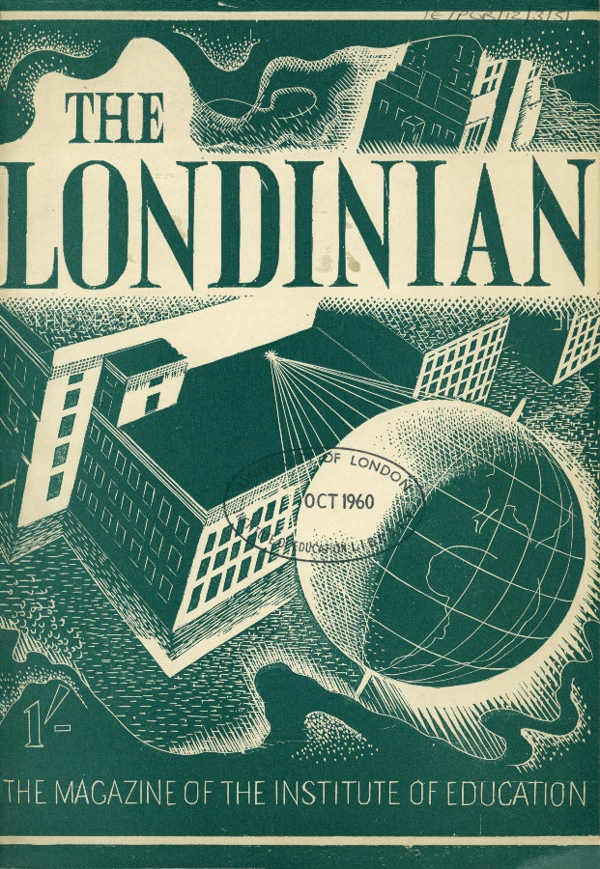

International Centre for Historical Research in Education (ICHRE)
International Online Conference
9 July 2020
Web: https://blogs.ucl.ac.uk/ichre/
Contact: ioe.ichre@ucl.ac.uk
Twitter: @ioe_ichre
Interactive outline
[To join each session please click the link]
08.30-9.00 Access open to Teams Meeting
09.00-9.10 Opening of conference (PLENARY)
9.10-9.30 Book Launches (PLENARY)
9.30-10.30 Parallel Session 1: Universities
Parallel Session 2: Lives
Parallel Session 3: School Culture
10.30-11.30 Break
11.30-12.00 Book Launches (PLENARY)
12.00-13.00 Parallel Session 4: Culture and Knowledge
Parallel Session 5: Teacher Training
Parallel Session 6: Teaching and Knowledge
13.00-14.30 Break
14.30-15.00 Book Launches (PLENARY)
15.00-16.00 Parallel Session 7: Education and Migration
Parallel Session 8: Interwar Education
Parallel Session 9: Internationalism
16.00-17.00 Break
17.00 -17.20 Book Launches (PLENARY)
17.20-18.20 Parallel Session 10: Texts and Education
Parallel Session 11: Childhood and Youth
Parallel Session 12: Education and Reform
18.20-18.30 Closing Remarks (PLENARY)

Full Programme

09.00-9.10 Opening of conference (PLENARY) Welcome: Gary McCulloch
9.10-9.30 Book Launches (PLENARY) Chair: Gary McCulloch

1) Mark Freeman
1.1 Angela Bartie, Linda Fleming, Mark Freeman, Tom Hulme, Alexander Hutton and Paul Readman (eds), Historical Pageants Local History Study Guide (St Albans: Regents Court Press, 2020). ISBN 978 1 916308 41 1 (paperback) 978 1 916308 42 8 (PDF). Open access.
1.2 Mark Freeman, The Pageants of St Albans: An Illustrated History (St Albans: Regents Court Press, 2020). ISBN 978 1 9163084 0 4 (paperback). RRP £16, available from:
1.3 Angela Bartie, Linda Fleming, Mark Freeman, Alexander Hutton and Paul Readman (eds), Restaging the Past: Historical Pageants, Culture and Society in Twentieth-Century Britain (London: UCL Press, 2020). ISBN 978 1 787354 05 0.
FORTHCOMING, ONLINE OPEN-ACCESS, AND HARD COPIES AVAILABLE FOR PRE-ORDER:

2) Carmen M. Mangion Carmen M. Mangion, Catholic Nuns and Sisters in a Secular Age, Britain 1945-1990 (Manchester University Press, 2020).

9.30-10.30 Parallel Sessions 1-3
Parallel Session 1: Universities Chair: Gary McCulloch

1A Tamson Pietsch: Comparing university funding in the United Kingdom and Australia across the 20th century
1B Antonio Fco. Canales: The Communist University of London in the 1970s: Ideological Renewal and Confluence of the British Left
1C Tom Woodin: The recent history of the (UCL) Institute of Education in wider perspective

Parallel Session 2: Lives Chair: Mark Freeman
2A Parimala V. Rao: Scottish Radicalism and A.O. Hume’s Educational Activities in India 1854-1867
2B Andrea Mariuzzo: Guido Calogero and the international models for Italian education reforms (1955-1963)
2C Tamara Colacicco: Lamberto Borghi and the impact of anti-Semitism in education

Parallel Session 3: School Culture Chair: Maria Williams
3A Fabio Pruneri: Time Management at School: A Historical Perspective (from the Fifteenth to the Nineteenth centuries)
3B Shaan Kashyap: A comparison between Colonial and Post-colonial “Textbook Culture”
3C Dawanji: Tent schools in Tibetan areas: towards a teacher oral history

10.30-11.30 Break

11.30-12.00 Book Launches (PLENARY) Chair: Georgina Brewis
1) Parimala V. Rao Parimala V. Rao, Beyond Macaulay: Education in India, 1780–1860 (Routledge UK and India, 2020)
2) Hsiao-Yuh
Hsiao-Yuh Ku, Education for Democracy in England in World War II (Routledge, 2020)

12.00-13.00 Parallel Sessions 4-6
Parallel Session 4: Culture and Knowledge Chair: Georgina Brewis
4A Manish Jain: Imagery of the White Man? ‘Citizen’, ‘Ward’, and the State in Bourinot’s Civics
4B Mazhar Hussain: Modern Science, the Pursuit of English Education and Reimagining Islamic Tradition: a preliminary inquiry
4C Marim Joice: Serampore Press: The rise of print culture in the Nineteenth Century India

Parallel Session 5: Teacher Training Chair: Tom Woodin
5A Sarabjeet Kaur: Teacher education during the colonial rule: establishment of Normal schools for primary school teachers in Punjab in nineteenth century
5B Qi Yarui: A Historical Investigation of the Transition from “Normal Education” to “Teacher Education” in China: A Foucauldian Perspective
5C Badegül Eren-Aydınlık: Secondary Schools, Teacher Training Colleges and the Educational Discourse in a Non-Western Context

Parallel Session 6: Teaching and Knowledge Chair: Gary McCulloch
6A Bhuwan Kumar Jha: ‘Malaviya’s idea on education: the founding of the Banaras Hindu University’
6B Cuihong Wu and Man Miao: Analysis of Educational History Research Status of China，2015-2019
6C Nandini Manjrekar: Public Education in the Mill District of Bombay, 1900-1940
6D Chandra Lekha Singh: Compulsory Elementary Education for Girls: A Study of Debates in Colonial India

13.00-14.30 Break

14.30-15.00 Book Launches (PLENARY) Mark Freeman
1) Gary McCulloch, Ivor Goodson, and Mariano González-Delgado
Gary McCulloch, Ivor Goodson, and Mariano González-Delgado, Transnational Perspectives on Curriculum History (Routledge, 2019)

2) Ann Marie Ryan, Charles Tocci and Seungho Moon Ann Marie Ryan, Charles Tocci and Seungho Moon, The Curriculum Foundations Reader (Palgrave Macmillan, 2020)

15.00-16.00 Parallel Sessions 7-9
Parallel Session 7: Education and Migration Chair: Maria Williams
7A Linda Chisholm: Education, Migration and Women’s Life Histories
7B Maria Williams: The Contribution of ‘A Sister of Notre Dame’, Mother Mary Charles Magdalene Walker and Phyllis Wallbank to Montessorian Education in Scotland, Nigeria, England and beyond.
7C Lajos Somogyvári: The Communist School Inside Out: Hungarian Emigrants’ Reports in the Early 1950s

Parallel Session 8: Interwar Education Chair: Tom Woodin
8A Diana Vidal and Rafaela Rabelo: The New Education Fellowship in South America (the 1920s-1950s)
8B Emma Papadacci: School practices and school life: the impact of war. United Kingdom – France, 1918 – 1939
8C Amy Zuberbueler: Thomas Edward Shields: Instructional Scaffolding in 1917
Parallel Session 9: Internationalism Chair: Mark Freeman
9A Anne Collignon: A Pioneer School of the International Baccalaureate: Copenhagen International School 1962-1973
9B Conan de Wilde: Alumni Surveys: A Historical Approach to Understanding Students’ Experiences of the Curriculum
9C Angelo Gaudio: The Difficult Internationalisation of Italian Education Discourse 1974-1980. The Case of Giovanni Gozzer
9D Marisa Bittar and Amarilio Ferreira Jr: Material on Soviet Education in the IOE Archive

16.00-17.00 Break

17.00-17.20 Book Launches (PLENARY) Chair: Tom Woodin
1) Rosa Bruno-Jofré 1.1 Rosa Bruno-Jofré, The Sisters of Our Lady of the Missions. From Ultramontane Origins to a New Cosmology (Toronto, Canada: University of Toronto Press,2020). 1.2 Rosa Bruno-Jofré (Ed.), Educationalization and its Complexities: Religion, Politics, and Technology (Toronto: ON: University of Toronto Press, 2019).
2) Tom Woodin Tom Woodin and Linda Shaw, eds, Learning for a Co-operative World: Education, Social Change and the Co-operative College (Trentham Books, IOE/UCL Press, 2019)

17.20-18.20 Parallel Sessions 10-12
Parallel Session 10: Texts and Education Chair: Tom Woodin
10A Michèle Cohen: ‘Curbed aspirations’? Girls’ education in children’s literature 1790-1830.
10B Nancy Rosoff: How to Play the Game: Instructions for American Female Athletes in the Early 20th Century
10C Kirstin Kukard: Case Study: A thematic analysis of two history textbooks that resisted apartheid ideology in the 1980s.

Parallel Session 11: Childhood and Youth Chair: Gary McCulloch
11A Kelly Power: Changing Childhoods: Discursive Constructions of the Child in the Mid-Nineteenth Century
11B Matthew Farrelly: John Muir as Educator: An Historical & Literary Sketch
11C Alexandra Pasqualone: From Schools to City Streets: Youth Activism in Philadelphia During the 1960s and 1970s

Parallel Session 12: Education and Reform Chair: Mark Freeman
12A Monica Rude: "Yes, it is fair”: How the late 1960s and Early 1970s Represented a Moment of Change in American University Admissions
12B Helen Lowe: Development of the Technical and Vocational Education Initiative in Scotland
12C Ruth Lupton, Lorna Unwin, (Stephanie Thompson, and Sanne Velthuis): Constructing Thresholds for ‘Success’ and ‘Failure’: A Critical Policy History of Examinations for 16-Year-Olds in England

18.20-30 Closing Remarks Gary McCulloch and Team

Thank you for participating today. This international online conference is a first for ICHRE and for many participants.

Gary McCulloch
Georgina Brewis
Mark Freeman
Tom Woodin
Maria Williams

