Guide for Disabled Users and Microsoft Teams

Michele Farmer and James Prime

Contents

Introduction 3

Visual Impairment (VI) 4

macOS Built-in Accessibility Tools 4

VoiceOver 4

Keyboard shortcuts for Microsoft Teams with MacOS using Voiceover Tool 5

General 5

Navigation 6

Messaging 7

Meetings and calls 7

Voiceover on Iphone or Ipad 7

Keyboard Shortcuts for Teams on Windows using JAWS 8

General 8

Navigation 8

Messaging 9

Meetings and calls 9

Windows 10 Built-in Accessibility Tools 10

Low Vision and Colour-Blindness 11

Windows 10 Built-in Accessibility Tools 11

MacOS Built-in Accessibility Tools 11

Display options 11

Zoom options 12

macOS Built-in Accessibility Tools 13

VoiceOver 14

Tools within Teams 14

Android Devices 17

Huawei Settings 17

Sony Settings 20

Apple iPhone/iPad 24

Teams for iPhone 27

Teams for iPad 28

Dyslexia 31

Windows 10 Built-in Accessibility Tools 31

macOS Built-in Accessibility Tools 32

Tools within the Teams Window 32

Apple iPhone/iPad 36

Teams for iPhone 40

Teams for iPad 41

TextHelp Read and Write (UCL users only) 44

Motor Impairment 45

Windows 10 Built-in Accessibility Tools 45

macOS Built-in Accessibility Tools 48

Keyboard options 48

Mouse and trackpad options 49

Switch control options 50

Dictation options 52

Apple iPhone/iPad Built-in Accessibility Tools 53

Teams for iPhone 57

Teams for iPad 58

Hearing Impairments 60

# Introduction

This guide’s purpose is to explain the best ways, and platforms, to use to access Microsoft Teams if you are a disabled user. We have endeavoured to cover as much as possible, however, this is such a complex program with many variations, and there will be some areas we have missed. Should you need further help, please contact us on ??????????

Microsoft Teams is cloud-based team collaboration software that is part of the Office 365 suite of applications. The core capabilities include business messaging, calling, video meetings and file sharing.

Each disabled user has their own requirements, and as Microsoft Teams layout and accessibility varies from platform to platform to mobile device, some will be easier to use than others.

The contents of this guide are broken down by disability.

Teams has both desktop applications, and web browser interfaces for both Mac and PC, and this leads to further complications due to the inconsistency of layout and accessibility features.

# Visual Impairment (VI)

Teams’ structural information can be problematic for some screen reader users who say that they experience difficulties building up a mental picture of the application.

Navigation commands are not particularly consistent throughout the program, and no indication is given when the change is needed.

From our feedback from blind users, the consensus seems to be that using the inbuilt accessibility tools of the iPhone, iPad and Apple devices in general, make it far easier to navigate than through the Windows environment.

## macOS Built-in Accessibility Tools

|  |  |
| --- | --- |
| **Action** | **Shortcut** |
| Display [Accessibility Options](https://support.apple.com/HT202562) | Option+Command+F5 or triple-press Touch ID (power button) |
| Turn VoiceOver on or off | Command+F5 or Fn+Command+F5 or hold Command and triple-press Touch ID |
| Open VoiceOver Utility, if VoiceOver is turned on | Control+Option+F8 or Fn+Control+Option+F8 |
| Turn zoom on or off | Option+Command+8 |
| Zoom in | Option+Command+Plus Sign (+) |
| Zoom out | Option+Command+Minus Sign (-) |
| Turn the [Invert colours setting](https://support.apple.com/kb/HT201899) on or off | Control+Option+Command+8 |
| Reduce contrast | Control+Option+Command+Comma (,) |
| Increase contrast | Control+Option+Command+Period (.) |

The table below provides [keyboard shortcuts for various macOS accessibility tools](https://support.apple.com/en-gb/HT204434).

### VoiceOver

VoiceOver is the macOS screenreader. Once enabled, it offers to show you through the training, which is a good idea if you have only previously used proprietary screenreaders such as JAWS, or have never previously used a screenreader at all, as the VoiceOver commands are quite different.

To turn VoiceOver on or off directly, use the keyboard shortcut Command+F5, bearing in mind that function keys may need to be accessed using the Fn key. To access the VoiceOver settings panel, press Command+Option+F5 to reach the accessibility settings; the keyboard focus will land in the search bar, and pressing the Tab key will bring you to the sidebar of options: “Display”, “Zoom”, “VoiceOver”, etc. VoiceOver is third in the list, so pressing the down arrow twice will bring up the VoiceOver options.

Alternatively, you can use Spotlight (for which the keyboard shortcut is Command+Space) to search for “Accessibility” to reach the accessibility settings, which may be the first or second result.

If your device supports Siri (macOS Sierra and later), you could also use voice recognition to open VoiceOver settings.

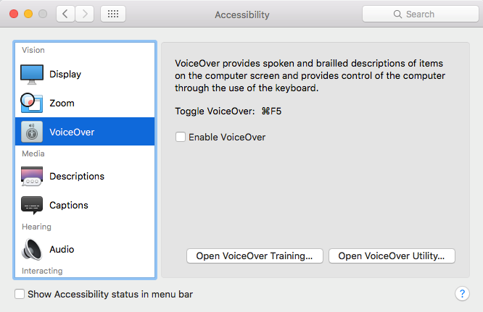

For the Mac users the following are the commands to get you started with using Teams.

## Keyboard shortcuts for Microsoft Teams with MacOS using Voiceover Tool

### General

| **Command** | **Shortcut on desktop version** |
| --- | --- |
| Show keyboard shortcuts | Command+Period (.) |
| Go to Search | Command+E |
| Show commands | Command+Slash (/) |
| goto | Command+G |
| Start new chat | Command+N |
| Open Settings | Command+Comma (,) |
| Open Help | F1 |
| Close | Esc |
| Zoom in | Command+Equals sign (=) |
| Zoom out | Command+Minus sign (-) |
| Return to default zoom | Command+0 |

| **Command** | **Shortcut on web version** |
| --- | --- |
| Show keyboard shortcuts | Command+Period (.) |
| Go to Search | Command+E |
| Show commands | Command+Slash (/) |
| goto | Command+G |
| Start new chat | Command+N |
| Open Settings | Command+Comma (,) |
| Open Help | Command F1 |
| Close | Esc |
| Zoom in | No shortcut |
| Zoom out | No shortcut |
| Return to default zoom | No shortcut |

### Navigation

| **Command** | **Shortcut on desktop version** |
| --- | --- |
| Open Activity | Command+1 |
| Open Chat | Command+2 |
| Open Teams | Command+3 |
| Open Meetings | Command+4 |
| Open Calls | Command+5 |
| Open Files | Command+6 |
| Go to previous list item | Option+Up arrow |
| Go to next item | Option+Down arrow |
| Move selected team up | Command+Shift+Up arrow |
| Move selected team down | Command+Shift+Down arrow |
| Go to the previous section | Command+Shift+F6 |
| Go to next section | Command+F6 |

| **Command** | **Shortcut on web version** |
| --- | --- |
| Open Activity | Command+Shift+1 |
| Open Chat | Command+Shift+2 |
| Open Teams | Command+Shift+3 |
| Open Meetings | Command+Shift+4 |
| Open Calls | Command+Shift+5 |
| Open Files | Command+Shift+6 |
| Go to previous list item | Option+Up arrow key |
| Go to next item | Option+Down arrow key |
| Move selected team up | No shortcut |
| Move selected team down | No shortcut |
| Go to the previous section | Command+Shift+F6 |
| Go to next section | Command+F6 |

### Messaging

| **Command** | **Shortcut on desktop version** |
| --- | --- |
| Go to compose box | C |
| Expand compose box | Command+Shift+X |
| Send (expanded compose box) | Command+Enter |
| Attach a file | Command+O |
| Start a new line | Shift+Enter |
| Reply to thread | R |

| **Command** | **Shortcut on web version** |
| --- | --- |
| Go to compose box | C |
| Expand compose box | Command+Shift+X |
| Send (expanded compose box) | Command+Enter |
| Attach a file | Command+Shift+O |
| Start a new line | Shift+Enter |
| Reply to thread | R |

### Meetings and calls

| **Command** | **Shortcut on desktop version** |
| --- | --- |
| Accept video call | Command+Shift+A |
| Accept audio call | Command+Shift+S |
| Decline call | Command+Shift+D |
| Start audio call | Command+Shift+C |
| Start video call | Command+Shift+U |
| Toggle mute | Command+Shift+M |
| Toggle video | Command+Shift+O |
| Toggle full screen | Command+Shift+F |
| Go to sharing toolbar | Command+Shift+Space |

| **Command** | **Shortcut on web version** |
| --- | --- |
| Accept video call | Command+Shift+A |
| Accept audio call | Command+Shift+S |
| Decline call | Command+Shift+D |
| Start audio call | Command+Shift+C |
| Start video call | Command+Shift+U |
| Toggle mute | Command+Shift+M |
| Toggle video | Command+Shift+O |
| Toggle full screen | Command+Shift+F |
| Go to sharing toolbar | Command+Shift+Space |

## Voiceover on Iphone or Ipad

The VoiceOver is a screen reader that lets you know what is happening on your iPhone or iPad, even if you can’t see on the screen. Use your finger to navigate and hear the interactions. It will read out dates/times, name of the person and the content of the message. You can adjust the Speaking Rate and Pitch to suit you.

## Keyboard Shortcuts for Teams on Windows using JAWS

### General

| **Command** | **Shortcut on desktop version** |
| --- | --- |
| Show keyboard shortcuts | Ctrl+. |
| Go to Search | Ctrl+E |
| Show commands | Ctrl+/ |
| Go to… | Ctrl+G |
| Start a new chat | Ctrl+N |
| Open Settings | Ctrl+, |
| Open Help | F1 |
| Close | Esc |
| Zoom in | Ctrl+= |
| Zoom out | Ctrl+- |

| **Command** | **Shortcut on web version** |
| --- | --- |
| Show keyboard shortcuts | Ctrl+. |
| Go to Search | Ctrl+E |
| Show commands | Ctrl+/ |
| Goto | Ctrl+Shift+G |
| Start a new chat | Alt+N |
| Open Settings | Ctrl+Comma, |
| Open Help | Ctrl+F1 |
| Close | Esc |
| Zoom in | No shortcut |
| Zoom out | No shortcut |

Navigation

| **Command** | **Shortcut on desktop version** |
| --- | --- |
| Open Activity | Ctrl+1 |
| Open Chat | Ctrl+2 |
| Open Teams | Ctrl+3 |
| Open Meetings | Ctrl+4 |
| Open Calls | Ctrl+5 |
| Open Files | Ctrl+6 |
| Go to previous list item | Alt+Shift+Up arrow |
| Go to next list item | Alt+Shift+Down arrow |
| Move selected team up | Ctrl+Shift+Up arrow |
| Move selected team down | Ctrl+Shift+Down arrow |
| Go to previous section | Ctrl+Shift+F6 |
| Go to next section | Ctrl+F6 |

| **Command** | **Shortcut on web version** |
| --- | --- |
| Open Activity | Ctrl+Shift+1 |
| Open Chat | Ctrl+Shift+2 |
| Open Teams | Ctrl+Shift+3 |
| Open Meetings | Ctrl+Shift+4 |
| Open Calls | Ctrl+Shift+5 |
| Open Files | Ctrl+Shift+6 |
| Go to previous list item | Alt+Up arrow |
| Go to next list item | Alt+Down arrow |
| Move selected team up | No Shortcut |
| Move selected team down | No Shortcut |
| Go to previous section | Ctrl+Shift+F6 |
| Go to next section | Ctrl+F6 |

### Messaging

| **Command** | **Shortcut on desktop version** |
| --- | --- |
| Go to compose box | C |
| Expand compose box | Ctrl+Shift+X |
| Send (expanded compose box) | Ctrl+Enter |
| Attach file | Ctrl+O |
| Start a new line | Shift+Enter |
| Reply to thread | R |
| Mark as important | Ctrl+Shift+I |

| **Command** | **Shortcut on web version** |
| --- | --- |
| Go to compose box | C |
| Expand compose box | Ctrl+Shift+X |
| Send (expanded compose box) | Ctrl+Enter |
| Attach file | Ctrl+Shift+O |
| Start a new line | Shift+Enter |
| Reply to thread | R |
| Mark as important | Ctrl+Shift+I |

### Meetings and calls

| **Command** | **Shortcut on desktop version** |
| --- | --- |
| Accept video call | Ctrl+Shift+A |
| Accept audio call | Ctrl+Shift+S |
| Decline call | Ctrl+Shift+D |
| Start audio call | Ctrl+Shift+C |
| Start video call | Ctrl+Shift+U |
| Toggle mute | Ctrl+Shift+M |
| Toggle video | Ctrl+Shift+O |
| Toggle full screen | Ctrl+Shift+F |
| Go to sharing toolbar | Ctrl+Shift+Space |

| **Command** | **Shortcut on web version** |
| --- | --- |
| Accept video call | Ctrl+Shift+A |
| Accept audio call | Ctrl+Shift+S |
| Decline call | Ctrl+Shift+D |
| Start audio call | Ctrl+Shift+C |
| Start video call | Ctrl+Shift+U |
| Toggle mute | Ctrl+Shift+M |
| Toggle video | Ctrl+Shift+O |
| Toggle full screen | Ctrl+Shift+F |
| Go to sharing toolbar | Ctrl+Shift+Space |

## Windows 10 Built-in Accessibility Tools

If you select the Windows key on your keyboard and carry out a search for Narrator, you have the following choices:

* Start Narrator automatically on PC bootup
* Choose a voice
* Change the speed and pitch of the voice
* Switch on intonation pause
* Sounds you hear – read hints for controls and buttons
* Order of contextual reading for controls and buttons
* Reading the characters or the words you type

# Low Vision and Colour-Blindness

There are various tools to improve the users’ access to the software. Both Windows and macOS have the following accessibility tools:

* High impact colour combinations, including high-contrast themes
* Zoom and magnification
* Screenreaders: VoiceOver (in macOS), or Narrator (in Windows)

Mac also has a colour overlay that you can apply to your screen, which allows you to specify your preferred colour and opacity.

## Windows 10 Built-in Accessibility Tools

If you select the Windows key on your keyboard and carry out a search for Magnifier, you will be provided with several options:

* Switch magnifier on
* Invert the colour combinations
* Tracking options
* Follow the mouse cursor
* Follow the keyboard focus
* Have Magnifier follow the text insertion point

There is a High Contrast option you can search for that allows you to modify colours for the following:

* Text
* Hyperlink
* Disabled text
* Selected text
* Button text
* Background

These will enable you to select colours that work best with your eyesight.

## MacOS Built-in Accessibility Tools

### Display options

The display in MacOS can be changed to greyscale, have the colours inverted, have contrast increased, have transparency reduced, or be differentiated without colour. The display contrast can be manually controlled via a slider, as can the cursor size. Shaking the mouse pointer, if enabled, will enlarge it for ease of finding it on the screen.

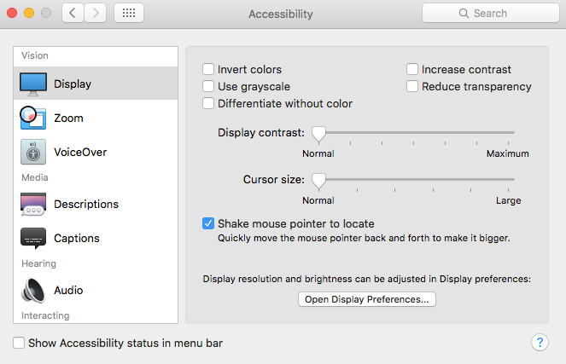

The purpose of differentiating without colour is to use shapes instead of – or alongside – colours to relay information, but it has been designed to have a subtle effect.

Increasing contrast via the checkbox in the display settings menu has the effect of, for example, darkening borders around elements, so they can be more easily distinguished from other elements.

### Zoom options

Zooming by shortcut can be enabled in the zoom options panel, as can zooming by finger gestures. The zoom can follow the cursor, or be fullscreen, or picture-in-picture. You can change different options depending on whether you choose fullscreen or picture-in-picture zoom style.

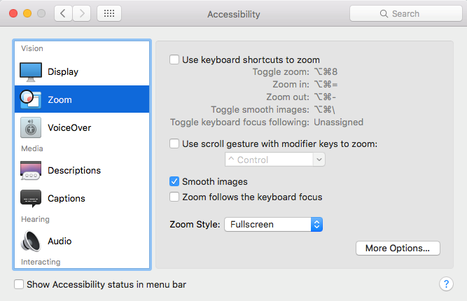

Zoom works well with Teams.

## macOS Built-in Accessibility Tools

|  |  |
| --- | --- |
| **Action** | **Shortcut** |
| Display [Accessibility Options](https://support.apple.com/HT202562) | Option+Command+F5 or triple-press Touch ID (power button) |
| Turn VoiceOver on or off | Command+F5 or Fn+Command+F5 or hold Command and triple-press Touch ID |
| Open VoiceOver Utility, if VoiceOver is turned on | Control+Option+F8 or Fn+Control+Option+F8 |
| Turn zoom on or off | Option+Command+8 |
| Zoom in | Option+Command+Plus Sign (+) |
| Zoom out | Option+Command+Minus Sign (-) |
| Turn the [Invert colours setting](https://support.apple.com/kb/HT201899) on or off | Control+Option+Command+8 |
| Reduce contrast | Control+Option+Command+Comma (,) |
| Increase contrast | Control+Option+Command+Period (.) |

The table below provides [keyboard shortcuts for various macOS accessibility tools](https://support.apple.com/en-gb/HT204434).

## VoiceOver

VoiceOver is the macOS screenreader. Once enabled, it offers to show you through the training, which is a good idea if you have only previously used proprietary screenreaders such as JAWS, or have never previously used a screenreader at all, as the VoiceOver commands are quite different.

To turn VoiceOver on or off directly, use the keyboard shortcut Command+F5, bearing in mind that function keys may need to be accessed using the Fn key. To access the VoiceOver settings panel, press Command+Option+F5 to reach the accessibility settings; the keyboard focus will land in the search bar, and pressing the Tab key will bring you to the sidebar of options: “Display”, “Zoom”, “VoiceOver”, etc. VoiceOver is third in the list, so pressing the down arrow twice will bring up the VoiceOver options.

Alternatively, you can use Spotlight (for which the keyboard shortcut is Command+Space) to search for “Accessibility” to reach the accessibility settings, which may be the first or second result.

If your device supports Siri (macOS Sierra and later), you could also use voice recognition to open VoiceOver settings.

## Tools within Teams

Within the actual message window within Teams if you click on the three dots, “…”, to the right of the message, and select “Immersive Reader”, you will be able to access more tools.

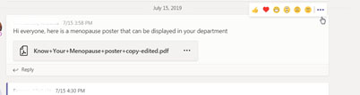

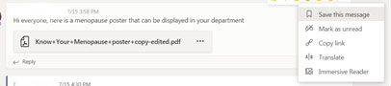

You will be able to change font, font size, and colour.

**Note** that this only works in the within Immersive Reader for each individual message, and not in the main Teams display.

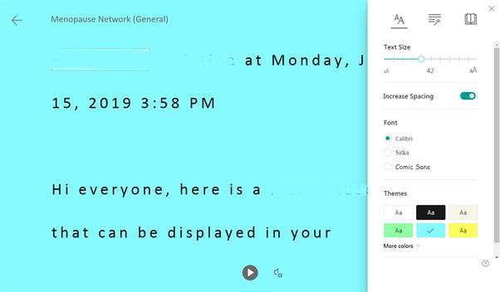

This obviously has its challenges in that you need to know which message to read in the first place.

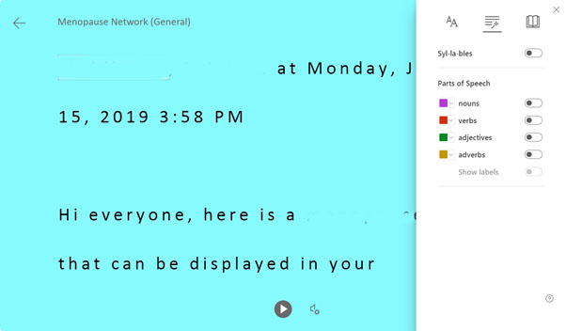

There is an option within the Immersive Reader that will read the text of the given message aloud, but this option again does not exist within the main Teams display.

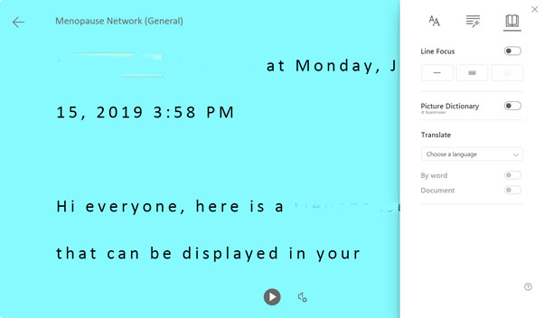

**Note** that to go back to the main Teams display from the Immersive Reader, you must click exactly on the centre of the back arrow, otherwise it will not work.

## Android Devices

Have Colour Correction, Colour Inversion and High Contrast Text if you need to modify colour and text.

Below are photos of two android devices Huawei and Sony to give you some examples of accessibility settings.

## Huawei Settings

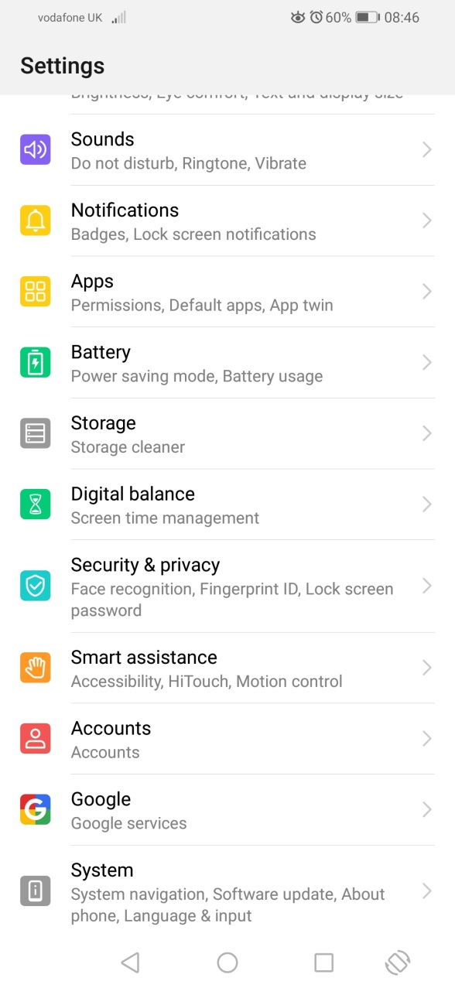

Accessibility tools are found under the Settings and Smart Assistance menus.

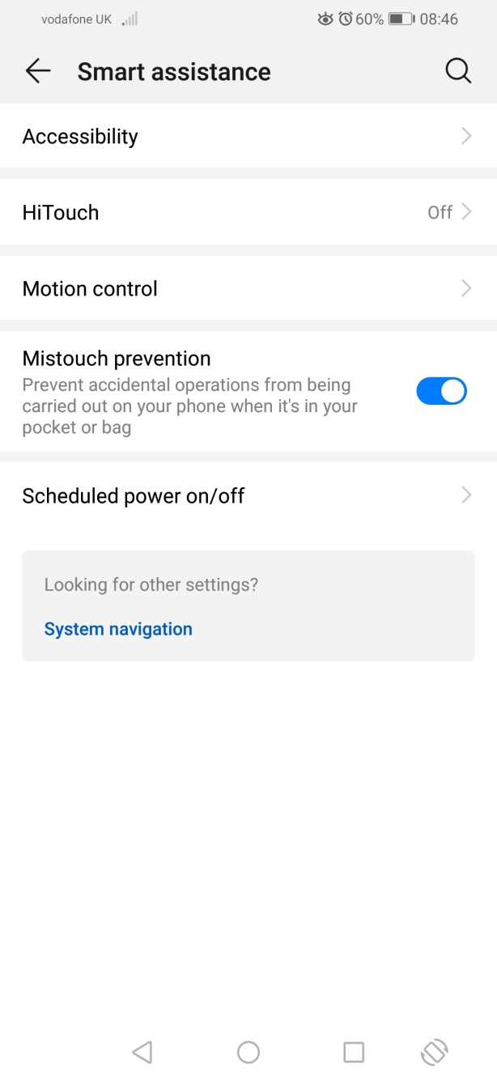

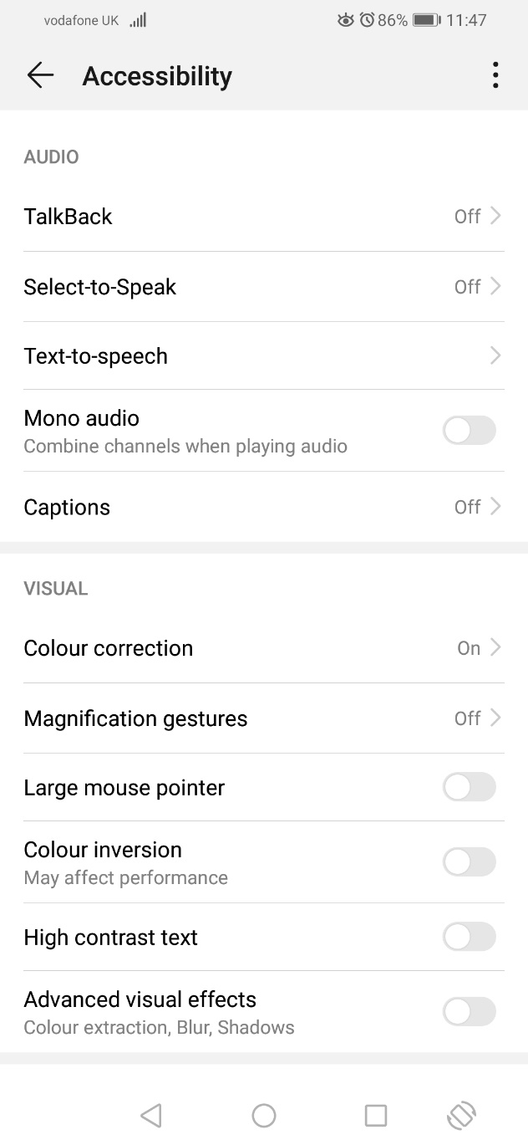

Under Accessibility you have the options of screen reading Talk Back, Select to Speak and Text to Speech.

Colour Correction, Magnification, Colour Inversion, High Contrast Text and you can also change the size of your mouse pointer.

## Sony Settings

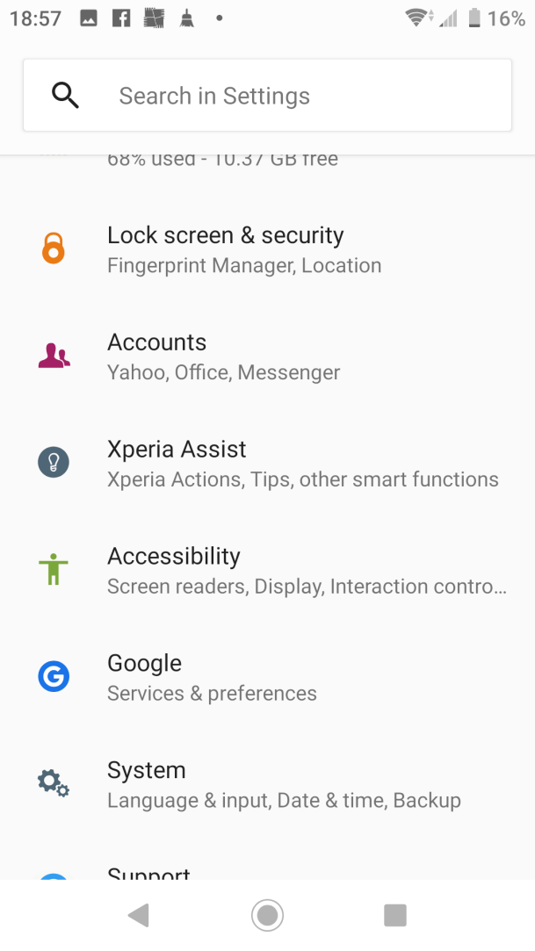

Accessibility tools are found under the Settings and Accessibility menus.

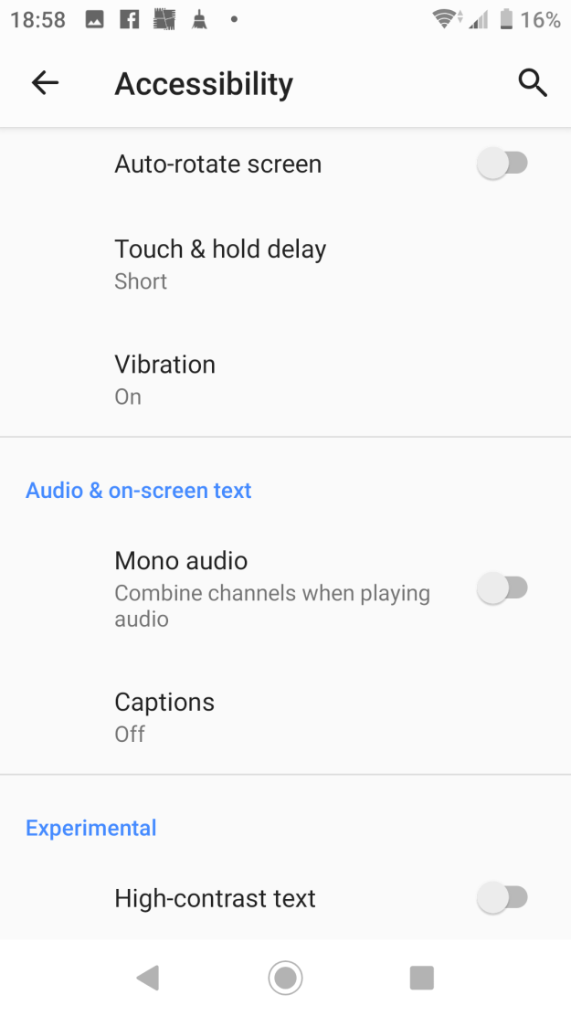

There is High Contrast Text and you can change the Font Size, Display Size, and Magnification as well as the screen reader TalkBack and text reader Select to Speak.

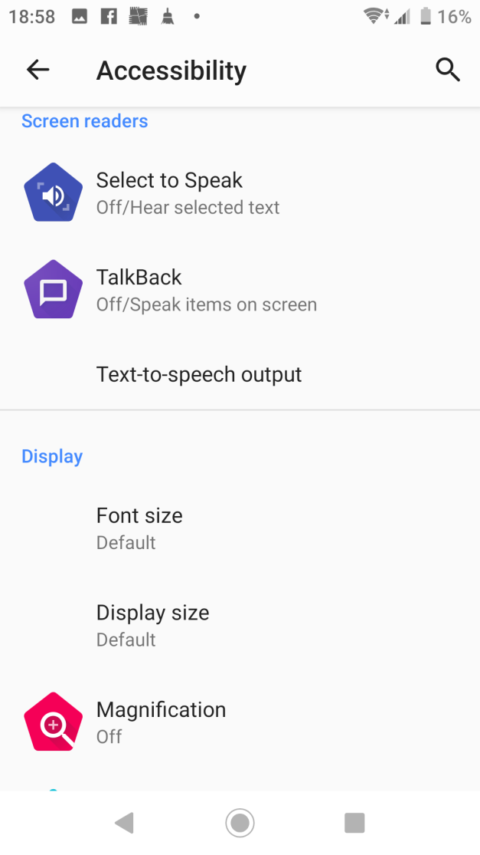

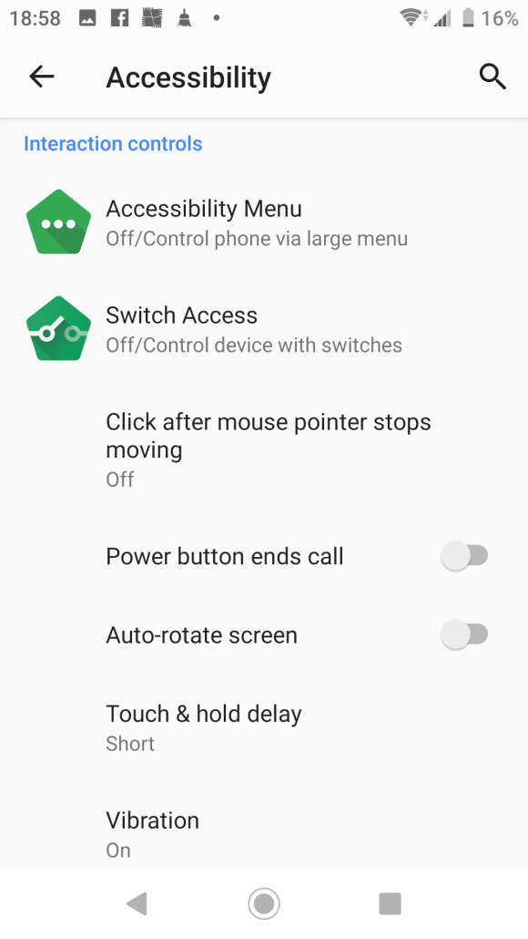

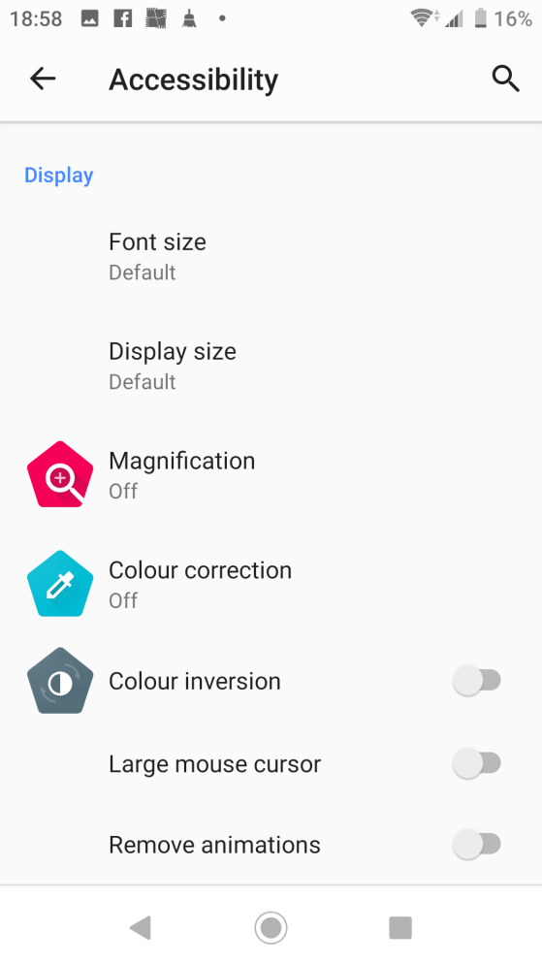

## Apple iPhone/iPad

Accessibility is all about ease of use and customisation to individual needs. It just makes technology better for everyone.

IPhone accessibility features include vision, hearing, physical and motor skills and educational settings that can allow people with a range of needs, to use iPhone and the world around them.

To find a range of Accessibility tools for users, go to Settings --> 

General --> Accessibility

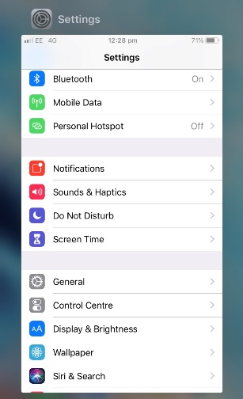

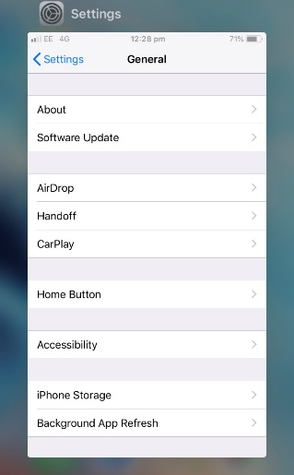

Here is the list of features for Accessibility access for users to use iPhone.

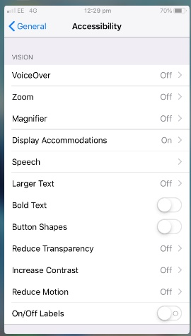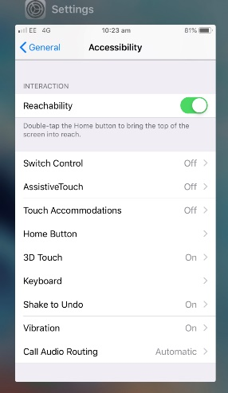 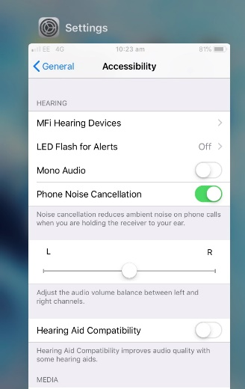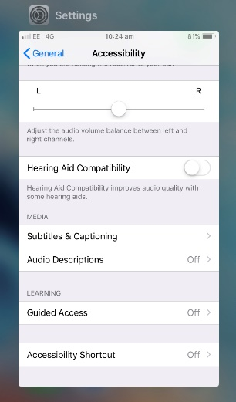  
There are another 8 great iPhone/iPad accessibility features: -

Invert Colours – The iPhone has multiple vision settings, low vision to colour blindness. Black colour on your screen is easier on your eyes or if you want to have less brightness while reading.

Magnifier – This tool is great to take a closer look. It will read small print, even in low light or turns your phone into a magnifying glass.

Larger Text Size – This allows you to adjust the size of your text. Move the slider up or down to adjust the preferred reading size

Zoom – You can zoom into the whole screen by double – tapping, or swiping 3 fingers across the whole screen and zoom up to 5 times.

Shake to undo – The iPhone has senses, by shaking it will undo typing for you.

Subtitles & Captioning – This is super convenient for the deaf. They can read on what is being said.

Accessibility Shortcut – If you want the ability to easily turn off something like invert colours, zoom or voiceover you can create a shortcut for one of these features.

Siri has the ability to make calls, set reminders, send messages through voice commands.



When you first sign in to the Microsoft Teams app, you land in the Feed menu view, which is on Activityicon.

The Activity icon contains activity feeds that contains conversations with other people in your team. You can browse conversations by clicking once and double clicking to open the conversation you want to reply in your team.

## Teams for iPhone

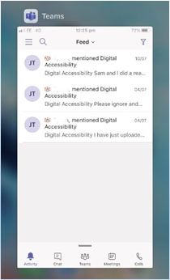

## Teams for iPad

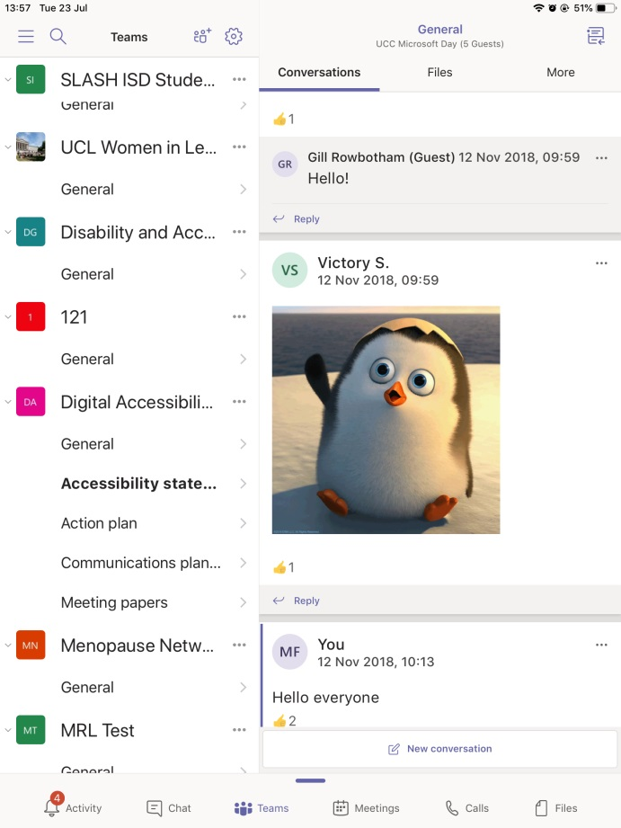

The Chat icon lists your recent messages or add a private chat. You can browse the messages list, open a message to write a reply, read a whole conversation and start a call, or share a file in a chat. You can also check a contact's details and start a private chat.

To go to the Chat icon, "Chat list." The focus is in the list of recent chats in the list pane.



The Teams will list recent Teams you are involved in and by swiping up and down will go to the different groups. Double click to select a Teams you want to read and can reply to any message.

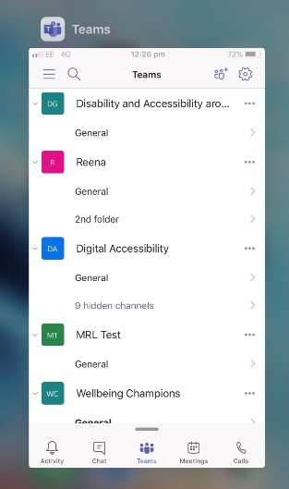

The VoiceOver is a screen reader that lets you know what is happening on your iPhone, even if you can’t see on the screen. Use your finger to navigate and hear the interactions. It will read out dates/times, name of the person and the content of the message. You can adjust the Speaking Rate and Pitch to suit you.

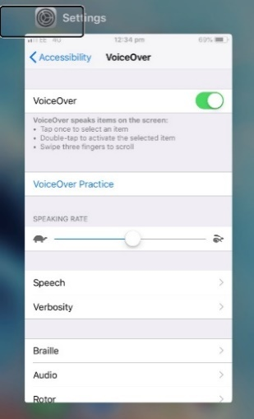

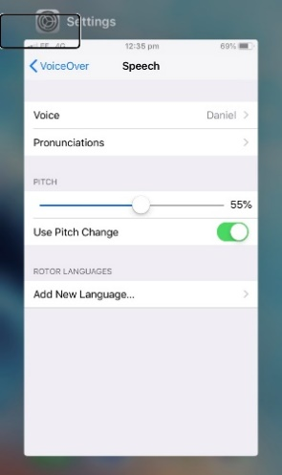

Select Speech to hear different types of voice options from either a male or female you want to hear read out the text on screen.

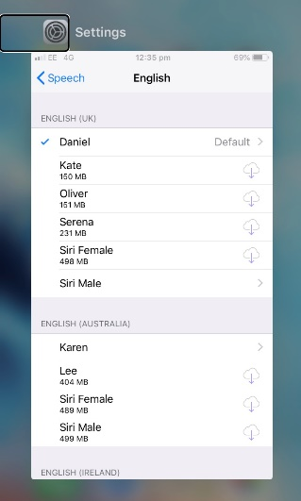

# Dyslexia

## Windows 10 Built-in Accessibility Tools

If you select the Windows Button on your keyboard and carry out a search for High Contrast.

There is a High Contrast option you can search for that allows you to modify the following colours:

* Text
* Hyperlink
* Disabled text
* Selected text
* Button text
* Background

These will enable you to select colours that work best with your colour sensitivity.

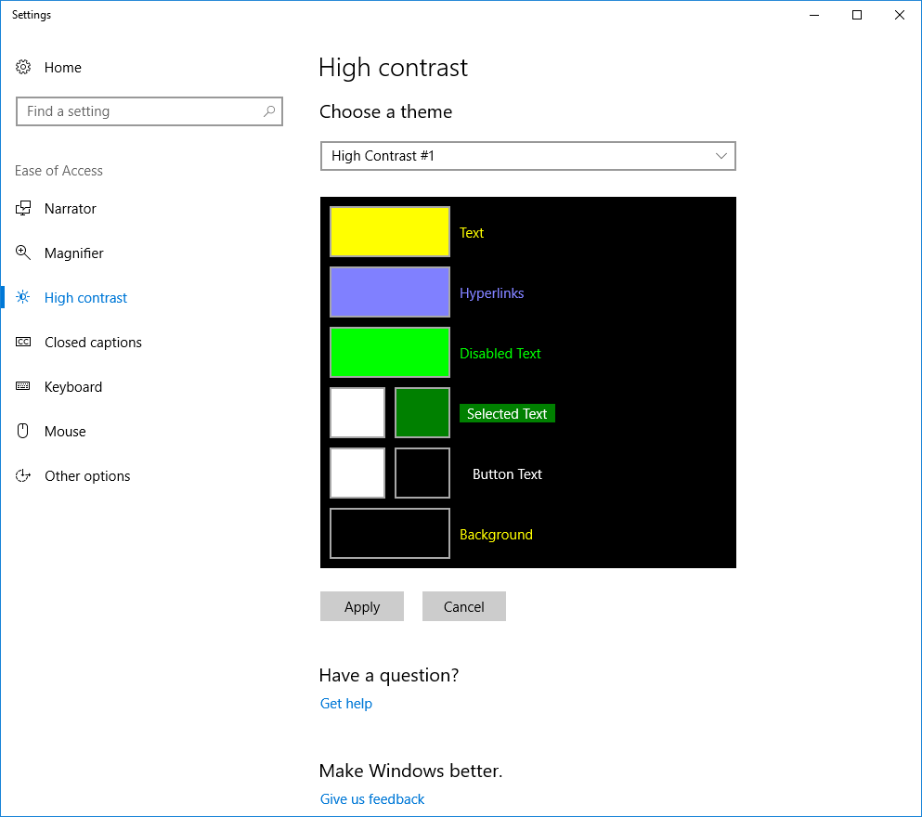

More settings can be found within the Ease of Access Center.

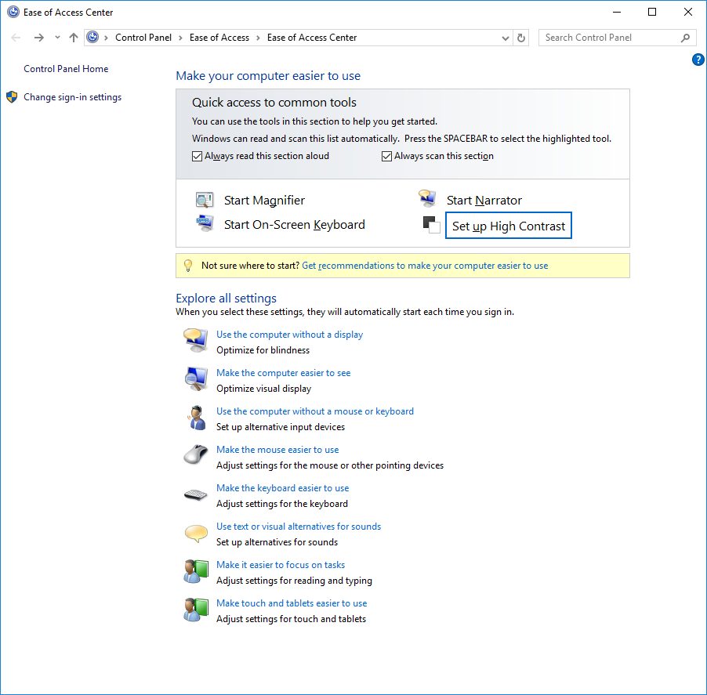

## macOS Built-in Accessibility Tools

See the Display options section earlier in this document. Page 11.

## Tools within the Teams Window

Within the actual message window within Teams if you click on the three dots … to the right of the message, you will be able to access more tools under the ‘Immersive Reader’ section.





You will be able to change font, font size, and colour *NOTE this only works in the individual message windows, and not in the rest of the program.



This is obviously has its challenges as you need to know which message you need to read out in the first place.



Also in the … menu there is the text reader which again sadly only works for the individual messages. This will read out loud the message you are in at that time.



To close this box you have to click exactly on the centre of the back arrow otherwise it will not work.

The layout can be too complex to be able to visually scan through on the desktop version so using mobile phones, or tablets, may prove better as it simplifies the layout of the program.

See image below for the Android view.

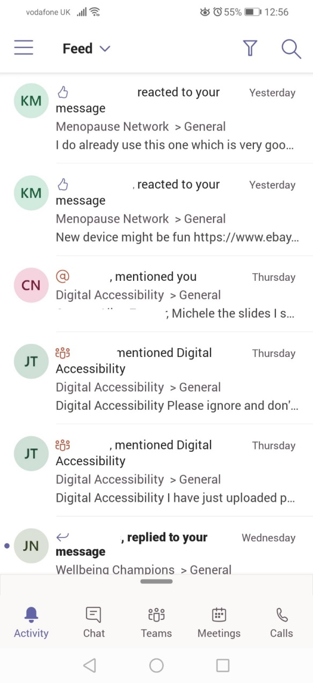

Android phones have a number of good accessibility tools to help you navigate and access Teams

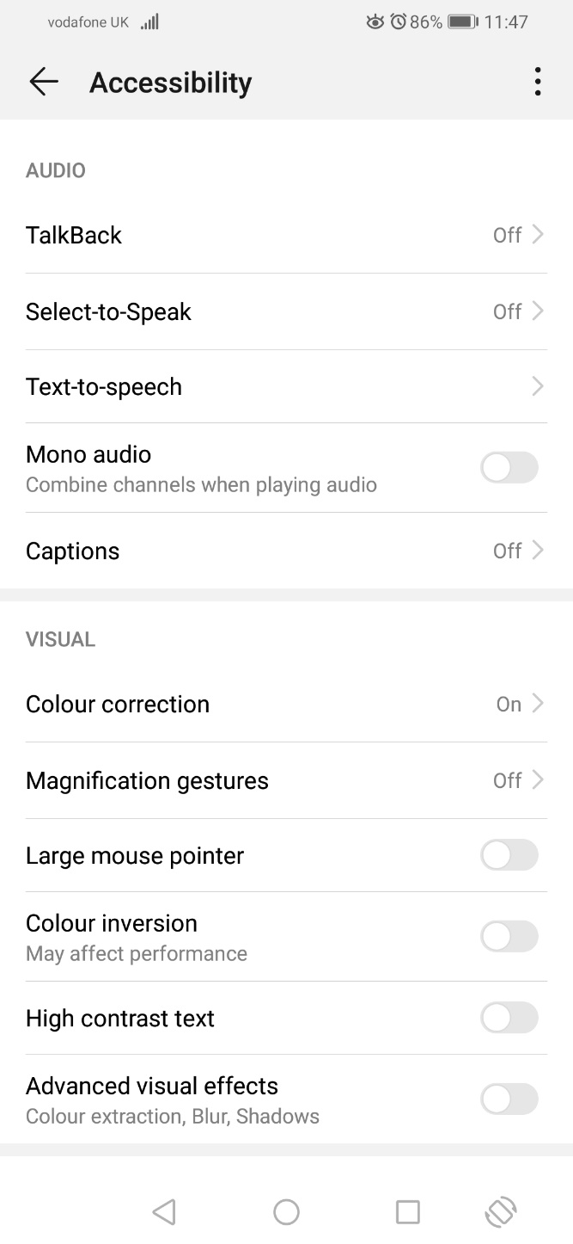

There are two talking apps, ‘Select to Speak’ and ‘Text-to-Speech’, which can read the text to you but you can also use ‘Colour Correction’,’ Colour Inversion’, and ‘High Contrast Text’, if you are colour sensitive.

### Apple iPhone/iPad

Accessibility is all about ease of use and customisation to individual needs. It just makes technology better for everyone.

IPhone accessibility features include vision, hearing, physical and motor skills and educational settings that can allow people with a range of needs, to use iPhone and the world around them.

To find a range of Accessibility tools for users, go to Settings --> 

General --> Accessibility





Here is the list of features for Accessibility access for users to use iPhone.

 

There are another 8 great iPhone/iPad accessibility features: -

Invert Colours – The iPhone has multiple vision settings, low vision to colour blindness. Black colour on your screen is easier on your eyes or if you want to have less brightness while reading.

Magnifier – This tool is great to take a closer look. It will read small print, even in low light or turns your phone into a magnifying glass.

Larger Text Size – This allows you to adjust the size of your text. Move the slider up or down to adjust the preferred reading size

Zoom – You can zoom into the whole screen by double – tapping, or swiping 3 fingers across the whole screen and zoom up to 5 times.

Shake to undo – The iPhone has senses, by shaking it will undo typing for you.

Subtitles & Captioning – This is super convenient for the deaf. They can read on what is being said.

Accessibility Shortcut – If you want the ability to easily turn off something like invert colours, zoom or voiceover you can create a shortcut for one of these features.

Siri has the ability to make calls, set reminders, send messages through voice commands.



When you first sign in to the Microsoft Teams app, you land in the Feed menu view, which is on Activityicon.

The Activity icon contains activity feeds that contains conversations with other people in your team. You can browse conversations by clicking once and double clicking to open the conversation you want to reply in your team.

## Teams for iPhone



## Teams for iPad



The Chat icon lists your recent messages or add a private chat. You can browse the messages list, open a message to write a reply, read a whole conversation and start a call, or share a file in a chat. You can also check a contact's details and start a private chat.

To go to the Chat icon, "Chat list." The focus is in the list of recent chats in the list pane.



The Teams will list recent Teams you are involved in and by swiping up and down will go to the different groups. Double click to select a Teams you want to read and can reply to any message.



The VoiceOver is a screen reader that lets you know what is happening on your iPhone, even if you can’t see on the screen. Use your finger to navigate and hear the interactions. It will read out dates/times, name of the person and the content of the message. You can adjust the Speaking Rate and Pitch to suit you.





Select Speech to hear different types of voice options from either a male or female you want to hear read out the text on screen.



## TextHelp Read and Write (UCL users only)

UCL has a site licence for the text to speech software Read and Write. This has numerous tools built in aside from the text to speech, including, screen colour overlay, colour ruler display, It is available for all UCL machines and if not listed in the desktop menu it can be found via the Software Center and the Software Database.



# Motor Impairment

## Windows 10 Built-in Accessibility Tools

If you select the Windows Button on your keyboard and carry out a search for On Screen Keyboard:

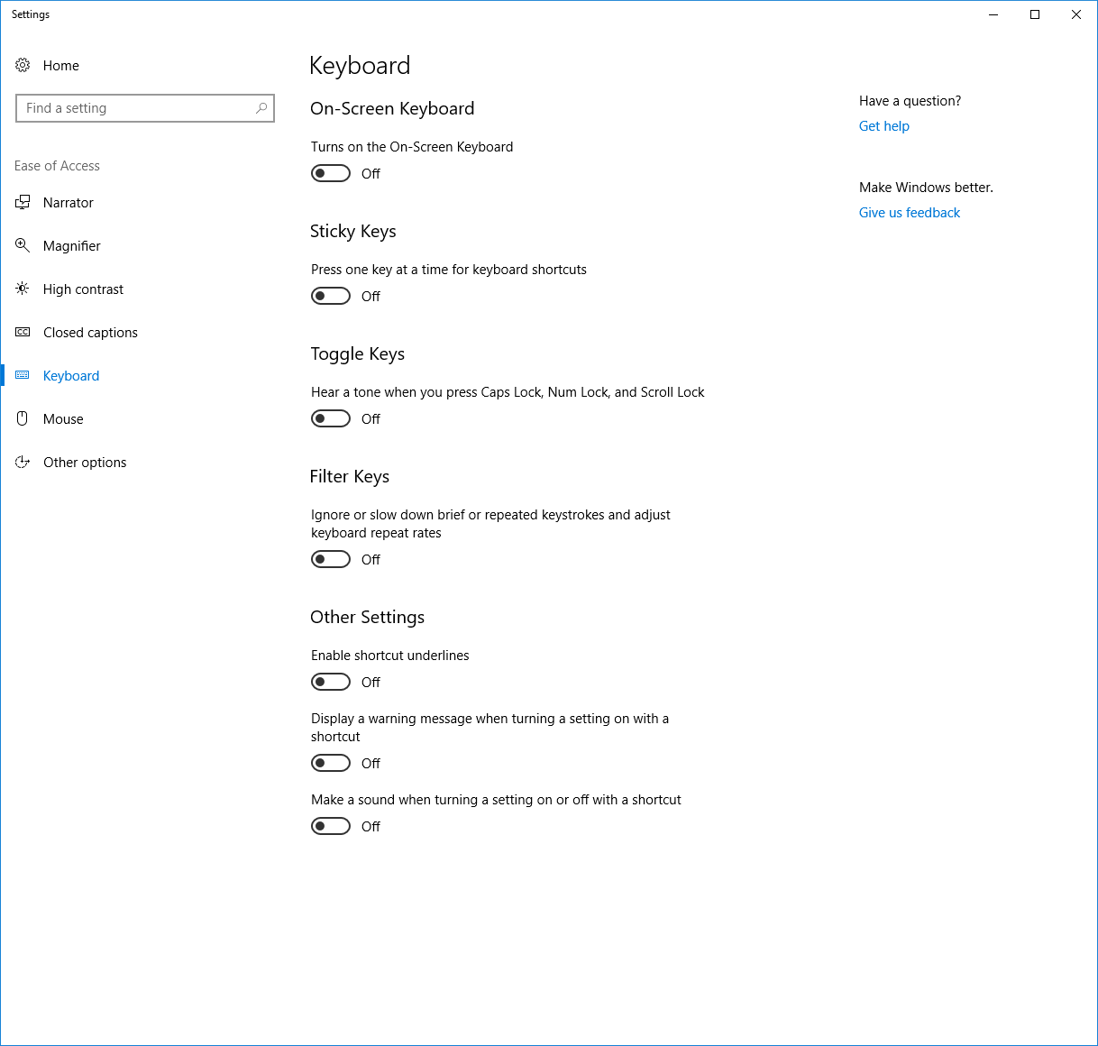

Keyboard Settings:

* On Screen Keyboard – This allows you to have a mouse operated visual keyboard on the screen of your monitor
* Sticky Keys – This allows for the mobility impaired to access multiple function keys
* Toggle Keys – This plays a sound when you press various function keys (Caps Lock, Num Lock, Scroll Lock)
* Filter Keys – This feature tells the keyboard to ignore brief or repeated keystrokes in order to make typing easier for users with hand tremors

Filter Keys:

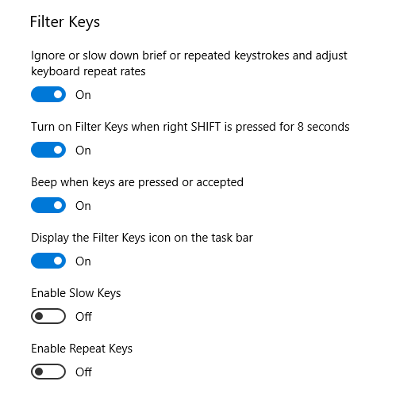

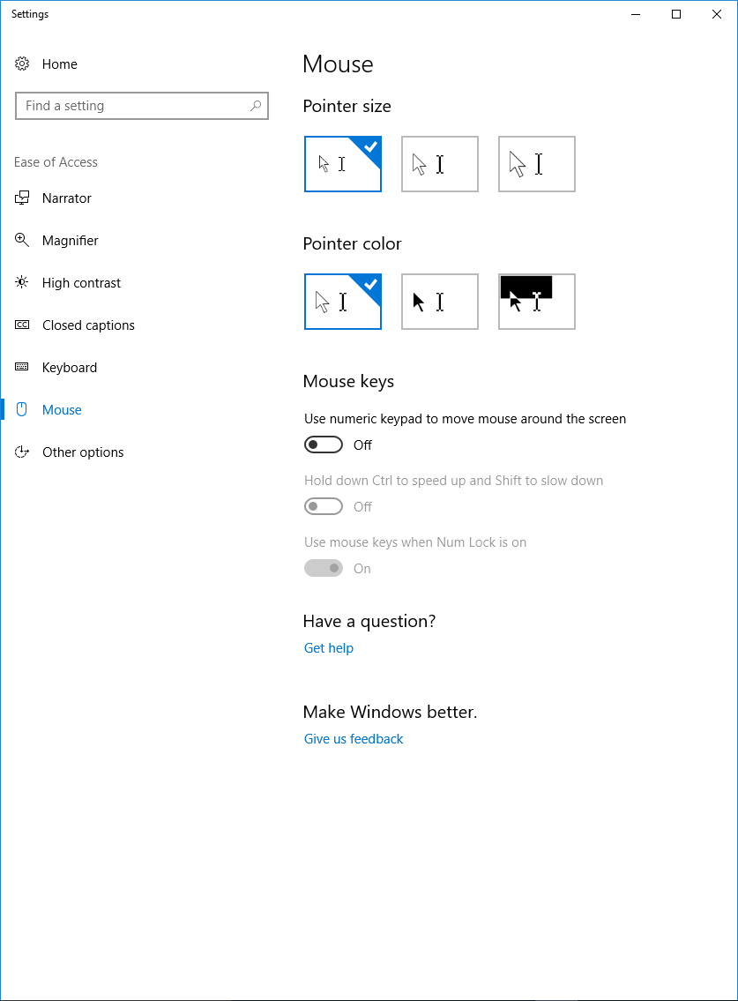

Mouse Settings – This allows various changes to the mouse, in size, colour, ability to operate a mouse using numeric keys, and change speed.

More settings can be found within the Ease of Access Center.



## macOS Built-in Accessibility Tools

### Keyboard options

These options allow you to enable StickyKeys and/or SlowKeys.

StickyKeys allows for modifier keys to be tapped (instead of held down) and retain their functionality as if they were being held down. For example, to capitalise a letter, with StickyKeys enabled, you would press and release Shift, then press the letter to be capitalised, rather than holding Shift while pressing the letter to be capitalised.

SlowKeys allows you to ensure keys aren’t registered as having been pressed when you haven’t meant to press them, by changing the length of time they must be pressed before they are registered.

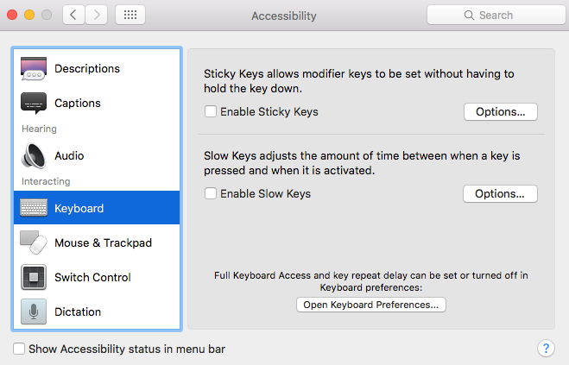

### Mouse and trackpad options

If your keyboard has a number pad, enabling Mouse Keys will allow you to control the mouse using the number pad.

You can also change the double-click speed and the spring-loading delay of the mouse, and if you are using an external mouse or trackpad, there is an option to disable the built-in trackpad when the external one is connected.

The double-click speed is how long between each click before a double-click is registered, which is useful if you frequently accidentally double-click.

The spring-loading delay is the feature on macOS which, when a file is dragged onto a folder and held over it, opens the highlighted folder without clicking being necessary.

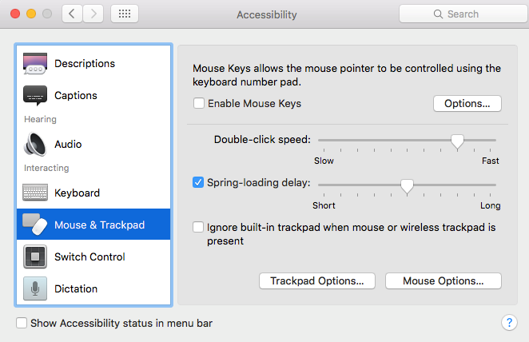

### Switch control options

The [switch control](https://support.apple.com/en-us/HT202865) options are designed to enable the computer to be controlled using input devices including, but not limited to, keyboards, mice, and gamepad buttons. In this context, a “switch” is a single key- or button-press that selects an item or performs an action. When enabled, the Home panel will come up on the screen, and will scan through items until you press the given switch to select the highlighted item.

These options have three tabs: General, Switches, and Navigation.

The General tab allows you to enable Switch Control as a whole, and to enable panel hiding after a specific user-set time.

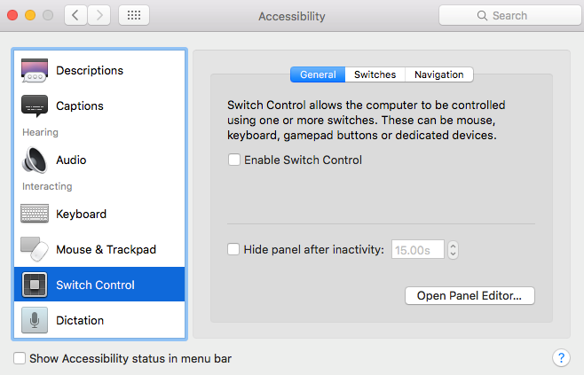

The Switches tab allows you to add specific switches, remove switches, or edit existing ones. You can also turn auto-scanning off, which is the default way to navigate between items in the Home panel, in which case you must define switches for additional navigation control as well as item selection.

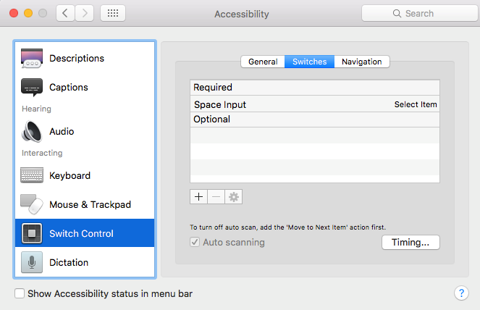

The Navigation tab provides settings to control the navigation within the Home panel with Switch Control enabled, such as the restart position, how to handle the pointer reaching the edge of the Home panel, cursor size, pointer precision, and number of loops to auto-scan across the Home panel before stopping.

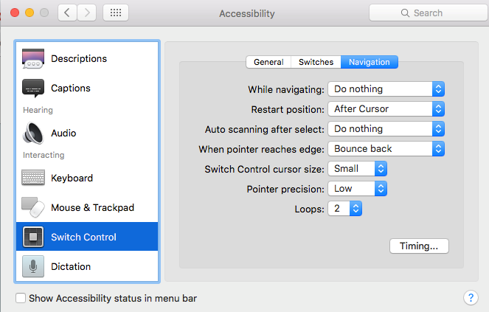

### Dictation options

macOS has built-in voice-recognition software, and the dictation options allow you to set a specific word with which it can be activated. You can also set a specific sound effect for when a command is recognised, and the muting of other audio while dictating.

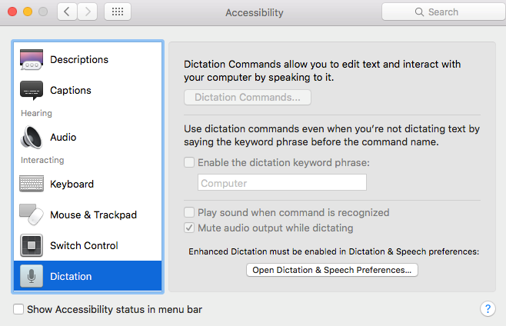

## Apple iPhone/iPad Built-in Accessibility Tools

Accessibility is all about ease of use and customisation to individual needs. It just makes technology better for everyone.

IPhone accessibility features include vision, hearing, physical and motor skills and educational settings that can allow people with a range of needs, to use iPhone and the world around them.

To find a range of Accessibility tools for users, go to Settings --> 

General --> Accessibility





Here is the list of features for Accessibility access for users to use iPhone.

 

There are another 8 great iPhone/iPad accessibility features: -

Invert Colours – The iPhone has multiple vision settings, low vision to colour blindness. Black colour on your screen is easier on your eyes or if you want to have less brightness while reading.

Magnifier – This tool is great to take a closer look. It will read small print, even in low light or turns your phone into a magnifying glass.

Larger Text Size – This allows you to adjust the size of your text. Move the slider up or down to adjust the preferred reading size

Zoom – You can zoom into the whole screen by double – tapping, or swiping 3 fingers across the whole screen and zoom up to 5 times.

Shake to undo – The iPhone has senses, by shaking it will undo typing for you.

Subtitles & Captioning – This is super convenient for the deaf. They can read on what is being said.

Accessibility Shortcut – If you want the ability to easily turn off something like invert colours, zoom or voiceover you can create a shortcut for one of these features.

Siri has the ability to make calls, set reminders, send messages through voice commands.



When you first sign in to the Microsoft Teams app, you land in the Feed menu view, which is on Activityicon.

The Activity icon contains activity feeds that contains conversations with other people in your team. You can browse conversations by clicking once and double clicking to open the conversation you want to reply in your team.

## Teams for iPhone



## Teams for iPad



The Chat icon lists your recent messages or add a private chat. You can browse the messages list, open a message to write a reply, read a whole conversation and start a call, or share a file in a chat. You can also check a contact's details and start a private chat.

To go to the Chat icon, "Chat list." The focus is in the list of recent chats in the list pane.



The Teams will list recent Teams you are involved in and by swiping up and down will go to the different groups. Double click to select a Teams you want to read and can reply to any message.

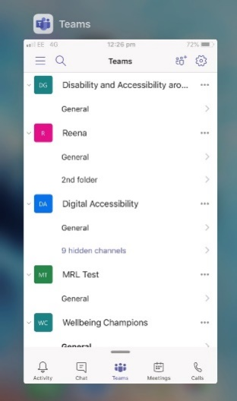

The VoiceOver is a screen reader that lets you know what is happening on your iPhone, even if you can’t see on the screen. Use your finger to navigate and hear the interactions. It will read out dates/times, name of the person and the content of the message. You can adjust the Speaking Rate and Pitch to suit you.





Select Speech to hear different types of voice options from either a male or female you want to hear read out the text on screen.



# Hearing Impairments

English (American) live captions are available for Teams meetings as a preview feature in the Desktop version of MS Teams.

To turn on live captions, click on the three dots in the meetings toolbar. From the pop-up list, select Turn on live captions (previee, English US only)

