Lecturecast indicator light- what does the colour indicate?

GREEN | SOLID RED | FLASHING YELLOW | FLASHING RED
 | 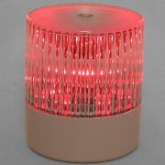 | 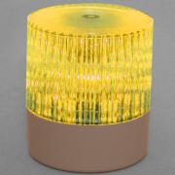
There is no scheduled recording taking place/Stand- By | Recording | Paused | Faulted/Disconnected
The Lecturecast unit is idle and ready to begin recording | The Lecturecast unit is recording | The recording is paused | The Lecturecast unit is faulty/disconnected

To pause/resume a recording:
To pause a recording, gently press down on the Delcom light for roughly one second. When you release your hand, the light will change from red to flashing yellow. While the light is flashing yellow your lecture recording will be paused and nothing will be recorded.
To resume the recording, gently press down on the light again for the same amount of time. When released, the light should change from flashing yellow to red, providing the scheduled end time of the recording has not been reached.
How to report a fault with your Lecturecast recording
If you have a scheduled recording and the Delcom light is flashing red, it indicates there is a technical fault with the system and your session is not being recorded.
Please called the Service Desk on the handset on the Podium (extension x25000) and ask to speak to the Digital Education team.

